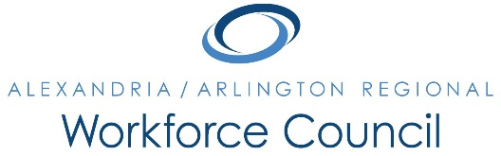

December 8, 2016
Arlington County Department of Human Services, Conference Room D
2100 Washington Blvd., Arlington, VA 22204
8:00 a.m. to 9:30 a.m.

Attendance: Lisa Bauer, Kate Bates, Karen Baugh, Sherri Chapman, Alessandra Colia, Dennis Desmond, Daniel Gomez, Ellen Harpel, Davis Harris, Elizabeth Jones-Valderrama, Alberto Marino, Kris Martini, Erik Pages, Steve Partridge, Dori Ramsey, Ann Randazzo, Andrea Rubino, Darren Tully

Absent: Eduardo Achach, Jeanne Booth, Patrick Brennan, Daniel Clarkson, Winoka Clements, Lisa Cortina, Lee Coyle, Howard Feldstein (One-Stop Operator), Carolyn Jones (One-Stop Operator), Stephanie Landrum, Kevin Lynch, Marc Olmsted, Cynthia Richmond, Marie Schuler, Rick Slusher

The meeting was called to order at 8:05 a.m.

A motion was made, seconded, and the minutes of the September 22, 2016 Regional Workforce Council meeting were unanimously approved.

PRESENTATIONS:
- Year-Up. Tamika Mason provided an overview of Year-Up’s DC Metro programming.

EXECUTIVE DIRECTOR’S REPORT:
- Incumbent Worker Program Update: infoLock Technologies, Inc. will be sending 5 employees to Northern Virginia Community College to earn their CISSP certifications.
- ETPL Application: Global Education Institute was unanimously approved for inclusion in the Council’s Eligible Training Providers List.
- Regional Planning Taskforce Update: The Council unanimously authorized Chair Gomez to sign the regional planning response letter to the Northern Virginia Workforce Development Board’s Chair.
- One-Stop Operator Procurement: The Council unanimously approved the Executive Director’s recommendation for procurement of a One-Stop Operator for the Alexandria/Arlington region.

UPDATE: ECONOMIC DEVELOPMENT, EDUCATION, AND WORKFORCE PARTNERS
- Representatives from the region’s education and workforce development community provided updates on their programming and events.

PUBLIC COMMENT PERIOD:
- No public comments.

The meeting was called to close at 9:30 a.m.

The next meeting will be held on January 26, 2017 at 8:00 a.m. in the Arlington County Department of Human Services’ Lower Level Auditorium.

