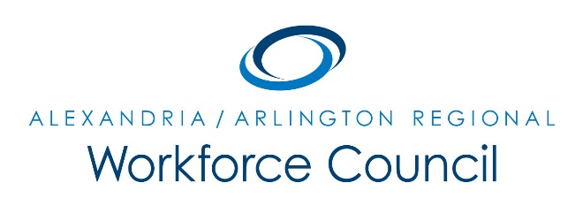

MEETING MINUTES

June 8, 2017

Arlington County Department of Human Services

2100 Washington Blvd, Lower Level Auditorium

Arlington, VA 22204

8:00 am to 9:30 am

Attendance: Eduardo Achach, Karen Brown, Jeanne Booth, Patrick Brennan, Sherri Chapman, Dennis Desmond, Howard Feldstein (One-Stop Operator), Daniel Gomez, Ellen Harpel, David Harris, Elizabeth Jones-Valderrama, Alberto Marino, Kris Martini, Daniel Mekibib (One-Stop Operator), Erik Pages, Dori Ramsey, Andrea Rubino, Marie Shuler, Darren Tully

Absent: Kate Bates, Lisa Bauer, Daniel Clarkson, Winoka Clements, Alessandra Colia, Lisa Cortina, Lee Coyle, Stephanie Landrum, Kevin Lynch, Marc Olmsted, Steve Partridge, Ann Randazzo, Cynthia Richmond, Andy Shreene, Rick Slusher, Landon Winkelvoss

The meeting was called to order at 8:05 a.m.

A motion was made, seconded, and the minutes of the March 9, 2017 Regional Workforce Council meeting minutes were unanimously approved.

PRESENTATIONS:
- Zachary Druga provided an overview of Potomac Job Corps, which serves low-income youth. This program can house and train up to 370 students and is one the largest resident job training programs in the country. The program offers various trades including building construction technology, carpentry, HVAC, and hospitality.
- Crystal Thrower provided an overview on the Registered Apprenticeship Program with its primary focus on the construction industry. They are now offering training in cyber security as well as other non-traditional trades.
- Alex Cooley, of Northern Virginia Community College, provided a labor market update.
- Doug Parsons, of Virginia Economic Development Partnership, provided an update.

EXECUTIVE DIRECTOR’S REPORT:
- David Remick provided reports and/or updates as follows:
  - Local WIOA Policies. A motion was made, seconded and the EO/General Grievance and Case Notes Polices were unanimously approved.
  - Eligible Training Provider. A motion was made, seconded and The Institute for Statistics Education was unanimously approved as a Certified Training Provider.
  - WIOA Funding Transfer Request. A motion was made, seconded and the request to transfer $60,616.77 of Dislocated Worker Funds to the Adult Program, was unanimously approved.
  - WIOA Youth Local Waiver. A motion was made, seconded and the WIOA Youth Local Waiver was unanimously approved.
  - 2017-2018 Meeting Calendar was presented.
  - Chair/Vice Chair Nomination. The call for nominations will be accepted throughout the summer. If you are interested in learning more, please contact David Remick.

UPDATE: ECONOMIC DEVELOPMENT, EDUCATION & WORKFORCE PARTNERS:
- Dennis Desmond reported needing 20-25 entry-level workers for Highway Construction Project starting July 1, 2017. Hours are 9:00 p.m. to 4:00 a.m. with a starting salary of $16.25 plus healthcare and must have own transportation.
- Naveen Hamdy reported on Goodwill’s Energy/Utility Class graduation. This was a collaborative project involving Washington Gas, Center for Energy Workforce Development, Alexandria Public Schools-Adult Education and others.
- Kris Martini reported having 22 participants for their Auto Industry Program. Upon graduation, students will have industry certifications and credentials.
- Sherri Chapman reported 2,400 certifications given to date in various education capacities.

NEW BUSINESS:
- Daniel Mekibib is the new Director of the Alexandria Workforce Development Center.
- Pam Egner provided a quick overview of the Arlington Employment Center’s new online job board.

PUBLIC COMMENT PERIOD: None.

The meeting was called to close at 9:34 a.m.

