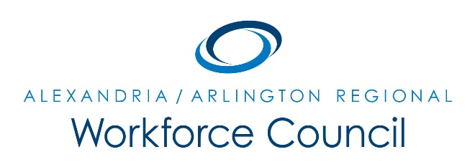

EXECUTIVE COMMITTEE MEETING AGENDA

October 14, 2016

8:30 am to 9:30 am

Welcome Message Daniel Gomez

LWDA 12 Update David Remick

- One-Stop Operations Committee & 2016/2017 One-Stop MOU
- CEDS Committee/Local Plan Update
- Regional Planning Update
- “What are the strategic discussions that you want to have?”

Next Steps/Adjourn Daniel Gomez

UPCOMING EXECUTIVE COMMITTEE MEETINGS

November 11, 2016

December 9, 2016

8:30 am to 9:30 am

Arlington County Employment Center Conference Room

2100 Washington Blvd, 1st Floor

Arlington, VA 22204

