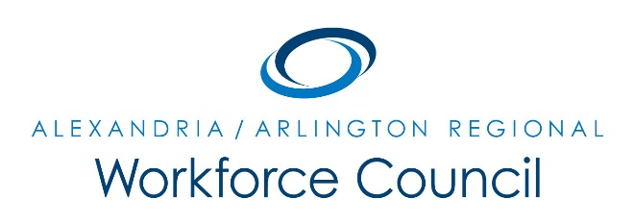

EXECUTIVE COMMITTEE MEETING AGENDA

November 17, 2017

8:30 am to 9:30 am

Welcome Message Daniel Gomez

One-Stop Operator Update Alamelu Dev

LWDA 12 Update David Remick

- Review of New Local WIOA Policy Changes
- Eligible Training Provider List Renewals
- Review of 12/7 RWC Meeting
- Membership Update

Next Steps/Adjourn Daniel Gomez

UPCOMING EXECUTIVE COMMITTEE MEETINGS

February 9, 2018

June 15, 2018

8:30 am to 9:30 am

Arlington County Employment Center Conference Room

2100 Washington Blvd, 1st Floor

Arlington, VA 22204

