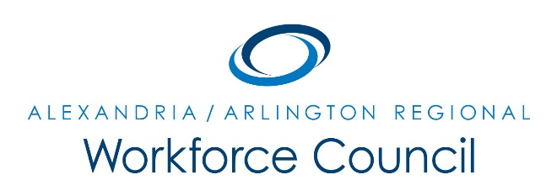

EXECUTIVE COMMITTEE MEETING NOTES

September 8, 2017

8:30 am to 9:30 am

Attendees: Dennis Desmond, Daniel Gomez, Ellen Harpel, Eric Pages
Absent: Teri Barnett, Lisa O'Quinn, Dori Ramsey
Staff: Alamelu Dev, Gabe Hamda, David Remick

- Meeting convened at 8:31am.
- David Remick introduced LWDA 12’s new, and first, One-Stop Operator, ICATT Consulting. ICATT’s representative to the Regional Workforce Council, Alamelu Dev, and its CEO, Gabe Hamda, provided an overview of their services and their scope of work as the One-Stop Operator.
- David Remick informed the Executive Committee that Daniel Gomez has been nominated as Chair for PY17 and PY18 and Alberto Marino has been nominated as Vice-Chair. Elections will take place during the October 5th Regional Workforce Council meeting.
- The Executive Committee approved the elevation of 1) LWDA 12 WIOA Policy Revisions and 2) $45,000.00 WIOA Funding Transfer Request to the Regional Workforce Council for their review and action.
- Meeting concluded at 9:30am

UPCOMING EXECUTIVE COMMITTEE MEETINGS

October 13, 2017

November 10, 2017

8:30 am to 9:30 am

Arlington County Employment Center Conference Room

2100 Washington Blvd, 1st Floor

Arlington, VA 22204

