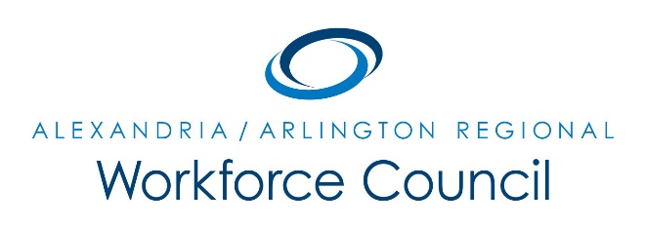

MEETING AGENDA

March 3, 2016

8:00 am to 10:00 am

Welcome Message Daniel Gomez

Presentation: University of Virginia Peter Wynne and Lisa O’Quinn

Exercise: Mapping NVA’s Workforce Conversation David Remick

Update: WIOA Implementation Daniel Gomez &
- RWC Strategic Plan David Remick
- 2016 Local Policies Approval
- WIOA Local Plan Orientation
- Regional Convener Updates

Update: Economic Development, Education, & Workforce Partners Various Speakers

New Business Daniel Gomez

Adjourn Daniel Gomez

UPCOMING MEETINGS

June 23, 2016

8:00 am to 10:00 am

Arlington County Department of Human Services

2100 Washington Blvd, Lower Level Auditorium

Arlington, VA 22204

