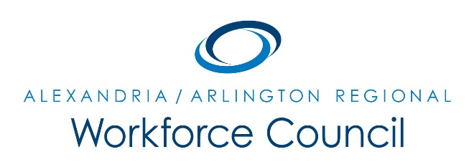

MEETING AGENDA

July 23, 2015

8:00 am to 10:00 am

- Welcome Message David Remick

- Chair & Vice-Chair Elections David Remick

- Presentation: Workforce Council Responsibilities David Remick

4. Update: Economic Development, Education, & Workforce Partners Various Speakers

5. New Business WC Chair

6. Adjourn WC Chair

UPCOMING MEETINGS

September 24, 2015

December 3, 2015

March 3, 2016

June 23, 2016

8:00 am to 10:00 am

Arlington County Department of Human Services

2100 Washington Blvd, LL Auditorium

Arlington, VA 22204

