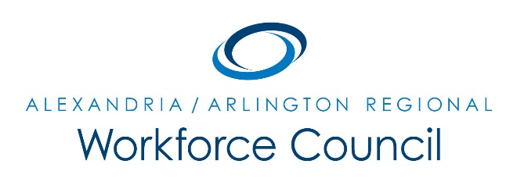
December 3, 2015

Arlington County Department of Human Services, Lower Level Auditorium
2100 Washington Blvd., Arlington, VA 22204
8:00 a.m. to 9:30 a.m.

Attendance: Eduardo Achach, Jeanne Booth, Sherri Chapman, Winoka Clements, Lee Coyle, Dennis Desmond, Howard Feldstein (One-Stop Operator), Daniel Gomez (Chair), Richard Gordon, Ellen Harpel, David Harris, Carolyn Jones (One-Stop Operator), Alberto Marino, Kris Martini, Lisa Miragliuolo, Marc Olmsted, Erik Pages, Dori Ramsey, Ann Randazzo, Cynthia Richmond, Kate Roche, Andrea Rubino, Rick Slusher, Darren Tully
Absent: Lisa Bauer, Karen Baugh, Patrick Brennan, Daniel Clarkson, Alessandra Colia, Lorinzo Foxworth, Elizabeth Jones-Valderama, Stephanie Landrum, Kevin Lynch, Sara Price, Maria Schuler
Guests: Teri Barnett and Jim Egenrieder
The meeting was called to order at 8:09 a.m.
A motion was made, seconded, and the minutes of September 24, 2015 were unanimously approved.
PRESENTATIONS:
- Adult Education Programs Supporting WIOA & Business: Teri Barnett provided an overview on three new program offerings – Certified Administrative Assistant; Certified Pharmacy Technician and Alexandria Energy Career Pathway Training. The presentation also highlighted the Workforce Innovation and Opportunity Act; staff roles and partnership agreements with CVS, Dominion Virginia Power, Pepco, Washington Gas and Pike Electric.
- NOVA Road Map to Regional Success Update: Jim Egenrieder provided highlights from the Committee’s September 25, 2015 meeting, which outlines its purpose, objectives and methodology and responses to the three questions –
  - What is the best way to forge a stakeholder partnership to promote the Northern Virginia Region?
  - What should Northern Virginia be doing as a region to attract and retain a changing workforce?
  - What is needed to ensure that the workforce pipeline is providing employees who are skill-set ready and appropriately credentialed?
- Survey: 27/7 Workforce Study: David Remick and Cynthia Richmond provided an overview on the partnership between the Alexandria/Arlington Regional Workforce Council and Arlington Economic Development to address the of Arlington’s 3rd Shift Workforce (11:00 p.m. to 7:00 a.m.). This partnership is looking at this issue from the employer, workforce, business opportunity and community perspectives. Keys questions were presented to the board members with feedback and discussion on the challenges faced for hiring and retention for this shift.

UPDATE: WIOA Implementation: The following policies were voted
- Council Bylaws and 2016 Local Policies – a motion was made, seconded, and the Council Bylaws was unanimously approved
- 2015 Local Policies – a motion was, seconded and the extension for 2015 Policies was unanimously approved
- Alexandria/Arlington Regional Convener Declaration – a motion was made, seconded, and the Regional Convener Declaration was unanimously approved
UPDATE: Economic Development, Education and Workforce Partners
- Cynthia Richmond provided highlights on economic development activity in Arlington
- Sherrie Chapmen provided an over of Alexandria City Public School programs
- Kris Martini announced a new initiative “Arlington Tech” for students starting in grades 9 through 12 and a Career Fair in May at the Career Center (see Kris for more details)
- Carolyn Jones reported that the position previously held by Dennis McKinney has been filled
- Howard Feldstein reports that the 5th Annual Career Fair hosted over 900 individuals and 51 employers represented
NEW BUSINESS:
- Virginia Employment Commission will host a one (1) day Career Fair on December 7, 2015
The meeting was called to close at 9:35 a.m. The next meeting is on March 3, 2016 at 8:00 a.m. at Arlington Department of Human Service’s Lower Level Auditorium

