WIOA ELIGIBLE TRAINING PROVIDER

The Americans with Disability Act Compliance Checklist

PROVIDER NAME: ___________________________________________________________________

Participants with disabilities should be able to arrive at your training site and easily locate and use accessible services
Accessible Parking |  |  |  |  |  | Yes | No
- Does your facility provide accessible parking spaces designed for use by individuals with disabilities?  - Does the parking areas have the minimum number of accessible parking spaces specified in the table (see page 4)?  - Are the accessible parking spaces located on the shortest possible accessible routes to the accessible building entrances?  - Are the accessible parking spaces located on a level area?  - Is each accessible parking space designed with a sign showing the International Symbol of Accessibility?  - Is there at least ONE van accessible space for every SIX accessible parking spaces?  - Are the van accessible parking spaces designed by an additional sign indicating “Van Accessible” (see figure)? |  |  |  |  |  |  |  |  | 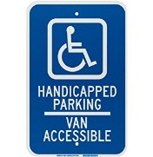  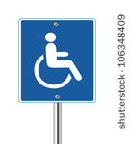
IT Accessibility
- Do images have alternative text?  - Does video have captions and does audio have a transcript?  - Do form fields within web pages and documents have appropriately coded labels and prompts?  - Does the interface have sufficient contrast between text color and background color?  - Does the content scale well when text is enlarged up to 200 percent?  - Can all menus, links, buttons, and other controls be operated by keyboard, to make them accessible to users who are unable to use a mouse?  - Do pages that have time limits include mechanisms for adjusting those limits for users who need more time?  - Have you avoided using content that flashes or flickers? |  |  |  |  |  |  |  |  | 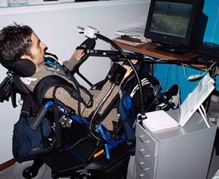
Accessible Approach and Entrance (Exterior Routes)
- Do accessible entrances have a minimum clear opening (free of protrusions and obstructions) of 32 inches?  - Is the force required to open accessible exterior entrances within a reasonable range?  - Are handles, pulls, latches, locks, and other operating devices on accessible doors easily grasped with one hand, and require no tight grasping, pinching, or twisting of the wrist to operate?  - Are the heights of thresholds at doorways ½ inch or less? |  |  |  |  |  |  |  |  | 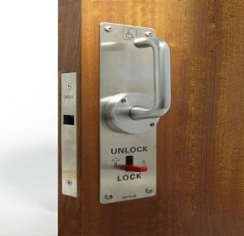
ACCESS TO GOODS AND SERVICES
- Do the interior doors in public areas have at least a 32-inch clear, unobstructed opening?  - Do the pull and push sides of doors have adequate maneuvering clearances in front of and to the sides of doorways so that a person using a wheelchair can position themselves to easily and safely open the door?  - Is every permanent room or space (such as restrooms, offices or meeting rooms, etc.) designed with a sign having good contrast between characters and background, adequate character size for viewing distance, raised (tactile) characters and Braille?  - Can interior doors be opened with 5 pounds or less force?  - Are door handles mounted no higher than 48 inches and no lower than 34 inches measured from the floor surface?  - Is adequate space available where turning spaces are needed or required for a wheelchair or other mobility device?  - If tables or work surfaces are available, is there a 36-inch aisle clearance between tables for wheelchair access?  - Do seating spaces at tables or work surfaces allow for a forward approach and provide a clear floor space of 30 by 48 inches?  - Are accessible tables and accompanying seating spaces distributed through the room or space?  - Do spaces under tables or work surfaces provide clear space for knees and toes?  - Do all exterior passage ways provide a minimum unobstructed head clearance (headroom) of 80 inches?  - Do ramps have a clear unobstructed width of at least 36 inches?  - Do ramps have a 5-foot long level landing at the top and bottom of each run?  - If the ramp rises more than 6 inches vertically, does it have handrails on both sides? |  |  |  |  |  |  |  |  | 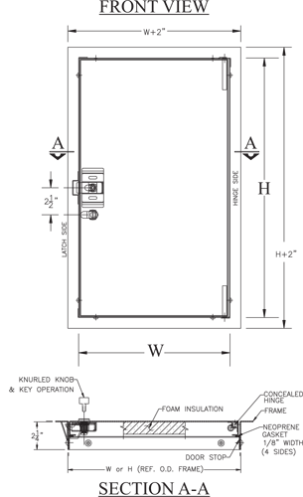  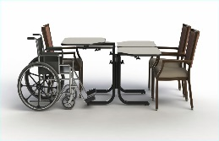
Elevators
- Does the building have passenger elevators?  - Are call buttons and keypads at elevators mounted no higher than 48 inches when measured to centerline of highest operable part above the floor?  - Are there raised (tactile) characters and Braille that indicate floor designations on both elevator jambs at the entrance to elevator mounted 48 to 60 inches above the floor surface?  - Are there both visible and audible signals to identify when an elevator car arrives and its direction of travel? |  |  |  |  |  |  |  |  | 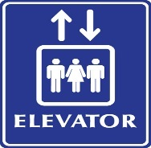
Drinking Fountains
- Where drinking fountains provided, are there two drinking fountains: one wheelchair accessible and one for persons who are standing?  - Does the wheelchair accessible drinking fountain provide a minimum knee clearance of 27 inches?  - Is there a 30 by 48-inch clear floor space positioned for a forward approach to the wheelchair accessible fountain? |  |  |  |  |  |  |  |  | 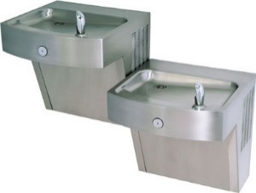
Restrooms
- Does your facility offer restrooms for public us?  - Are all accessible restrooms clearly designated with a sign having the International Symbol of Accessibility and mounted on the latch side of the door so the bottom edge of the highest tactile characters are 60 inches maximum and the lowest tactile characters are 48 inches minimum from the floor surface?  - Do the doorways of accessible restrooms have a minimum clear?  - Is there adequate turning space for a wheelchair or other mobility devices inside the restroom? |  |  |  |  |  |  |  |  | 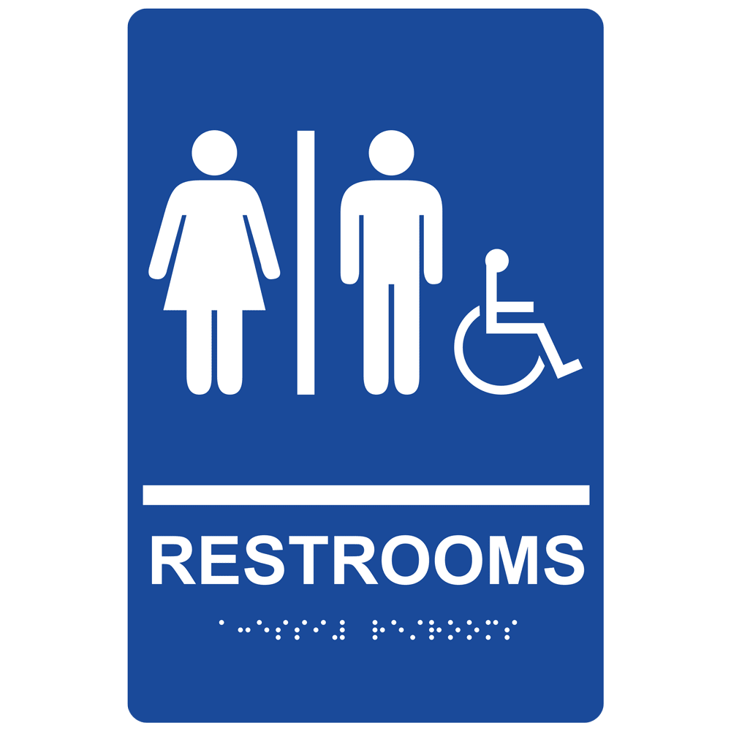
Signage
- Is adequate signage placed in standardized, appropriate locations throughout the building or facility?  - Does the signage identifying permanent rooms or spaces provide both raised (tactile) characters and Braille?  - Is exterior signage available at non-accessible entrances and along walkways that provides directions to the accessible routes and entrances?  - Is interior directional signage provided at inaccessible toilet rooms and elevators directing the person to nearest accessible toilet rooms and elevators. |  |  |  |  |  |  |  |  | 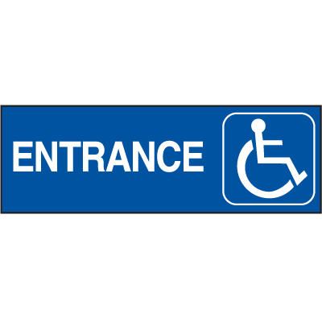
I certify that the above information is accurate and true to the best of my ability.

Name of Authorized Representative |  |  |  |  |  |  |  | Date:
Title:

Email: |  |  |  | Telephone:

The Americans with Disabilities Act (ADA) became law in 1990. The ADA is a civil rights law that prohibits discrimination against individuals with disabilities in all areas of public life, including jobs, schools, transportation, and all public and private places that are open to the general public.

Number of Accessible Spaces

Total Parking Spaces

1 to 25
26 to 50
51 to 75
76 to 100
101 to 150
151 to 200
201 to 300
301 to 400
401 to 500
501 to 1000
1001 and over

Designated Accessible Parking

1
2
3
4
5
6
7
8
9
2% of total
20 plus 1 for each 100 over 1000

