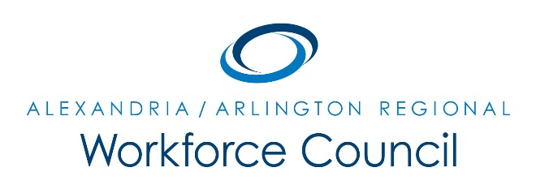

EXECUTIVE COMMITTEE MEETING AGENDA

September 8, 2017

8:30 am to 9:30 am

Welcome Message Daniel Gomez

Introduction of One-Stop Operator David Remick

One-Stop Operator Update Alamelu Dev

LWDA 12 Update David Remick

- Review of Local WIOA Policy Changes
- Review of 10/5 RWC Meeting
- Other Updates

Next Steps/Adjourn Daniel Gomez

UPCOMING EXECUTIVE COMMITTEE MEETINGS

October 13, 2017

November 10, 2017

8:30 am to 9:30 am

Arlington County Employment Center Conference Room

2100 Washington Blvd, 1st Floor

Arlington, VA 22204

