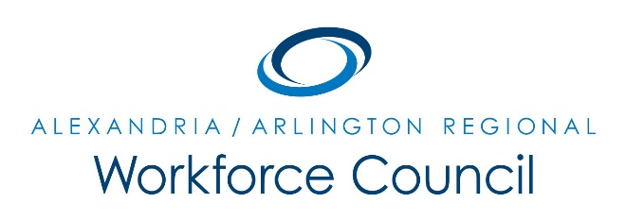

MEETING AGENDA

March 9, 2017

8:00 am to 10:00 am

Welcome Message Daniel Gomez

Presentation: Labor Market Update Alex Cooley

Executive Director’s Report David Remick
- Local Plan Approval/Career Services Waiver/Operator Update
- Comprehensive Economic Development Plan Update
- Eligible Training Providers Policy/DC Central Kitchen Waiver
- WIOA Performance Measures Overview

Update: Economic Development, Education, & Workforce Partners Various Speakers

New Business Daniel Gomez

Public Comment Period David Remick

Adjourn Daniel Gomez

UPCOMING MEETINGS

June 8, 2017

8:00 am to 10:00 am

Arlington County Department of Human Services

2100 Washington Blvd, Lower Level Auditorium

Arlington, VA 22204

