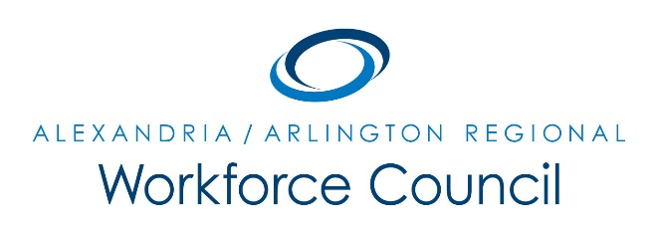

September 24, 2015

Arlington County Department of Human Services, Lower Level Auditorium
2100 Washington Blvd., Arlington, VA 22204
8:00 a.m. to 9:30 a.m.

Attendance: Lisa Bauer, Karen Baugh, Patrick Brennan, Sherri Chapman, Alessandra Colia, Lee Coyle, Dennis Desmond, Howard Feldstein (One-Stop Operator), Lorinzo Foxworth, Daniel Gomez (Chair), David Harris, Carolyn Jones (One-Stop Operator), Elizabeth Jones-Valderama, Stephanie Landrum, Kevin Lynch, Kris Martini, Marc Olmsted, Erik Pages, Dori Ramsey, Cynthia Richmond, Kate Roche, Marie Schuler, Rick Slusher, Darren Tully
Absent: Eduardo Achach, Jeanne Booth, Daniel Clarkson, Winoka Clements, Richard Gordon, Ellen Harpel, Alberto Marino, Lisa Miragliuolo, Sara Price, Ann Randazzo, Andrea Rubino
Guests: Duane Rohr, Jonathan Weiss
The meeting was called to order at 8:05 a.m.
A motion was made, seconded, and the minutes of July 23, 2015 were unanimously approved.
PRESENTATIONS:
- Military & Defense Contractor Workforce Situation/Trends: Jonathan Weiss provided an overview on the current situation and trends of military and defense contractor workforce. Two new initiatives are underway – DoD Skill Bridge and Force of the Future; both are designed to transition career soldiers from military to civilian workforce with skill-ready credentials.
- CVS Health’s Staffing and Workforce Demand: Duane Rohr provided an overview on the growth/expansion of the company. CVS has the following in-demand positions - Store Management and Pharmacy Technician Trainees. CVS will be hosting a Job Fair on September 28, 2015 from 10:00 a.m. to 1:00 p.m., at the Arlington Employment Center.
WIOA Implementation Update:
- Executive Committee Creation: This committee will define the work of the Council over the next year, gather data from staff that will help inform the Council’s efforts, develop the Council’s Bylaws and List of Committees, develop the Council’s Local WIOA Policies, and recommend and develop a process for Council approval of Eligible Training Providers. The Committee will meet on the 2nd Friday of each month from 8:30 a.m. to 9:30 a.m. by phone or in-person. The Committee members are Richard Gordon, Ellen Harpel and Dennis Desmond. The Committee will be led by Daniel Gomez and Eric Pages. A motion was made to establish the Executive Committee, seconded, and unanimously approved.
- GO Virginia: This is a state-wide grassroots campaign to mobilize business and community leaders, partners in education and government, and interested citizens to work for state policies that will help secure a future of expanding opportunity for all Virginians. A motion was made to allow Chair Gomez to sign up for the GO Virginia Initiative, seconded, and unanimously approved.
- Extension of Local Policies: A motion was made to extend the current set of local WIA policies to the end of the year. It was seconded and unanimously approved.
- Regional Convener Declaration: This requirement to HB1986 is up for public comment. A vote will be made to accept the Declaration at the Council’s December 3, 2015 meeting.
Economic Development, Education and Workforce Partners UPDATE:
- Stephanie Landrum provided highlights of economic development activities in Alexandria.
- Cynthia Richmond provided highlights of economic development activities in Arlington.
- Sherrie Chapman provided an overview of Alexandria City Public School programs.
- Kris Martini announced a new initiative “Arlington Tech”.
- Lorinzo Foxworth provided highlights from Northern Virginia Community College.
- Carolyn Jones reported that Alexandria WDC partnered with Together We Bake for their Culinary Arts Program. 11 out of the 12 participants completed their SafeServ Credentials.
- Howard Feldstein reports that on October 17, 2015 the Arlington Employment Center will host its 5th Annual Career Fair at George Mason University.
NEW BUSINESS:
- Eric Pages announced that Arlington’s WERA AM Community Radio Station will go live on December 9, 2015. This will be a great forum for communities and businesses to talk about their services and products.
The meeting was called to close at 9:35 a.m. The next meeting is on December 3, 2015 at 8:00 a.m. in Arlington Department of Human Services’ Lower Level Auditorium.

