Completing the WIOA Adult/DW PLAN: Objective Assessment Summary and Individualized Employment Plan

October 21st, 2020

Arlington Employment Center
2100 Washington Blvd.
Arlington, VA 22204

TRAINING DISCLAIMER
These materials are intended to assist WIOA Workforce Development Staff as they strive to improve their knowledge and understating of WIOA Case Management Practices & Procedures. While we attempt to thoroughly address specific topics, it is not possible to include discussion of everything necessary to ensure that the customer’s entire needs are being met and addressed. Thus, this information must be understood as a tool for addressing case management procedures related to the Employment Plan, rather than an exhaustive statement of a WIOA staff’s obligations, which are defined by statute, regulations, and standards. Likewise, to the extent that this information references practices or procedures that may enhance customer’s self-sufficiency, it cannot, and does not, create additional legal obligations. Finally, over time, State & Local monitors may modify rules and interpretations in light of new information, or circumstances; to keep apprised of such developments, or to review information on a wide range of WIOA & VAWC topics, you can visit US Department of Labor WIOA Guidance, Virginia WIOA Policies, and/or refer to the VOS Staff User Guide (located: VAWC > Staff Online Resources > VOS Staff Services User Guide > Section 4: Individuals – Case Management)

WIOA UPDATES
Electronic Case Files: as of October 1, 2020, WIOA staff must record and document activities for all new participants enrolled in WIOA Title I (Youth, Adult, and Dislocated Worker) programs in the VAWC (electronically). If you have any questions and/or concerns, please review the Virginia Workforce Letter (VWL) No. 20-07 for additional guidance. This can also be found in the Policies & Agreements page in the Alexandria/Arlington Regional Workforce Council website, click here to navigate to the website.

Table of Contents

The Individual Employment Plan…………………………………………………………..5
Staff Profiles – Case Management Profile 7
Plan Tab 8
Objective Assessment Summary (OAS) 9
Individual Employment Plan/Service Strategy (IEP/SS) 20
Creating a New Individual Employment Plan/Service Strategy (IEP/SS) 22
Goals & Objectives 24
Working with Existing IEP Plans 34

The Individual Employment Plan

Program Framework & Design

The IEP is built using the WIOA Program Framework and Design from the
Virginia WIOA Title I Case Manager Learning and Resource Manual PY 2019 Edition
Adults and dislocated workers who are determined to be eligible for WIOA and are enrolled in WIOA services complete a comprehensive, objective assessment of their skill levels, aptitudes, interests, abilities, and supportive service needs, leading to the development of an individual career plan called an Individual Employment Plan (IEP) that identifies a career goal and a continuum of services needed for the person to achieve economic security (meaningful employment). The WIOA Adult and Dislocated Worker programs has four main elements, as described below.

- Intake Activities involve services such as registration, eligibility determination, and the collection of information to support verification of eligibility for services. They may also include prescreening potential participants and general orientation to self-help services. Other activities include referrals to other services.

- Objective Assessment is a process that includes a review of the participant’s academic and occupational skill levels, as well as service needs and strengths, for the purpose of identifying appropriate services and career pathways for the participant and informing the individual service strategy. A new Objective Assessment is not required if the program provider determines that it is appropriate to use a recent objective assessment that was developed under another education or training program.

Case Management

Individual Employment Plan

Objective Assessment

Intake Activities

- The Objective Assessment generally includes content from the initial assessment and the comprehensive assessment and may also include the identification of interests, abilities, aptitudes, and supportive service needs, as well as measures of barriers and strengths. It includes a review of basic and occupational skills, work experience, employability potential, and developmental needs. The result of an assessment is an IEP with a service strategy.

- The IEP identifies the participant’s employment goals and educational objectives and prescribes appropriate services for the participant. The IEP is a living and breathing document developed with the participant to establish their career pathway choice and defining their current state and any activities/services necessary to achieve the stated employment goals and objectives.
- The IEP should contain the following:
- Assessment results and their interpretation.
- Goals and objectives leading to employment.
- Training and credential-related activities.
- Other activities necessary to achieve goals and objectives.
- Supportive service needs and activities.
- Referrals for additional services from partners and/or co-case management activities, as appropriate.
- Regular status updates on progress toward achievement of the stated employment goals and objectives.
- The intent is for the IEP to provide for:
- Preparation for postsecondary educational opportunities.
- Strong links between academic and occupational learning.
- Preparation for unsubsidized employment opportunities in appropriate cases.
- Effective connections to intermediaries with strong links to the job market and local and regional employers.

- Individual service strategies should also include information on local adult and dislocated worker activities and referrals to the providers of those services. Any adult and dislocated worker may receive information and referrals, regardless of their eligibility for the Adult and Dislocated Worker programs. These activities may be funded by sources other than WIOA.

- Case management is a participant-centered approach used to ensure that goals, activities, and services in the IEP are being met. This approach keeps adult and dislocated workers actively engaged and on a path to success in their employment and life. Case management includes the provision of services to the participant by a case manager in support of the achievement of the goals outlined in the participant’s IEP.

Staff Profiles – Case Management Profile

Four tabs deal with various aspects of case management in the Case Management Profile in the Staff Profile:

- Case Summary – This tab is identical to the Summary tab in the General Profile. See the Summary tab description starting on page 4-3 for details.
- Programs – Enables staff to create the application and participation forms for various federal programs and then record the services, outcomes, and closures for a program.
•
Plan – Enables staff to record the Objective Assessment Summary (OAS) and Individual
Employment Plan/Service Strategy (IEP/SS) for the individual.

- Assessments – Where assessment results are recorded that are instrumental in determining crucial elements of federal program enrollments.

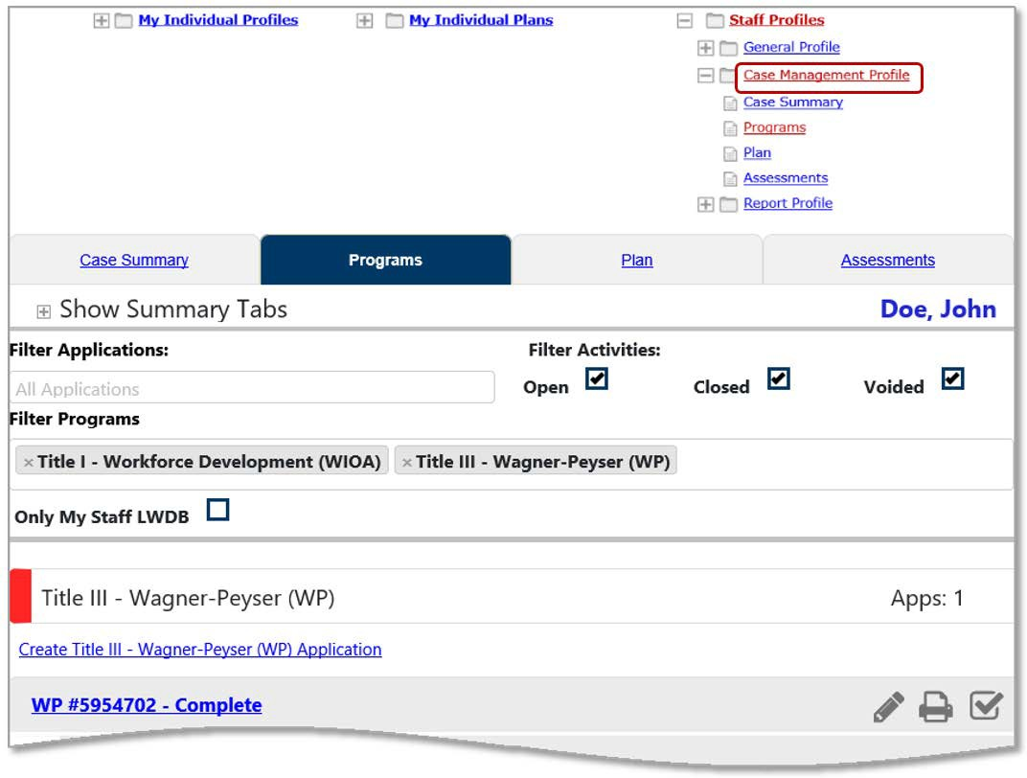
Case Management Profile Tabs
Plan Tab
The Plan tab lets staff create and manage an individual’s career goals and skills assessments using two functions: the Objective Assessment Summary (OAS) and the Individual Employment Plan (IEP).
This information combined provides a comprehensive plan for each program that helps direct the nature and number of program services provided to the individual.
NOTE: You will need to create an OAS and an IEP before you enroll an individual into any services (activities) for the appropriate program. Examples of Activity/Service codes used by staff to track the process & development of the OAS and IEP are 101 – Orientation, 102 – Initial Assessment, 107 – Provision of Labor Market Research, 202 – Career Guidance/Planning, 203 – Objective Assessment, 205 Develop Service Strategies (IEP/ISS/EDP)

Plan Tab: From this page, staff can create, modify, print, or delete both the OAS and IEP.

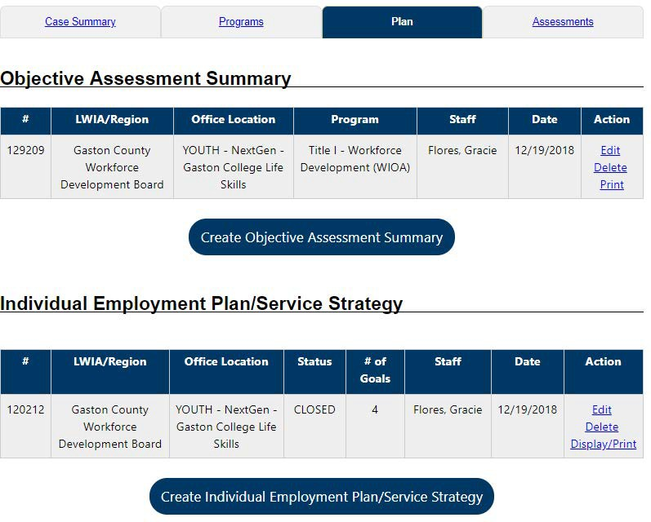
In the Objective Assessment Summary (OAS); an individual’s academic levels, skill levels, and service needs are recorded
In the IEP, their employment and career goals, achievement objectives, and the appropriate services are recorded.

Objective Assessment Summary (OAS)
The Objective Assessment Summary (OAS) is used to satisfy program requirements for recording results of Vocational Skill Assessments or Objective Assessment activities.

The data collected in the assessment process for employment and training programs is commonly used to assess vocational skills and aptitudes as related to employability, job seeking, and self-sufficiency. The OAS is therefore key to developing a robust IEP to meet the client’s future goals of employment and self-sufficiency.

Note: Staff can associate an OAS record to an open Individual Employment Plan (IEP), however, there is no link to associate OAS results to Goals and Objectives set in the IEP/SS form.

- To create an Objective Assessment Summary (OAS):

- Click the Create Objective Assessment Summary button on the Plan tab of the Case Management Profile. This starts a 12-page OAS wizard and displays the General page (see figure below).
Note: Some fields on the following pages may be pre-populated based on entries from the individual’s general info and background data. Some data can be changed for OAS purposes.

Select the correct Program (WIOA Adult, WP, TAA), office location
(AEC/AWDC), LWIA (Arlington Alexandria)

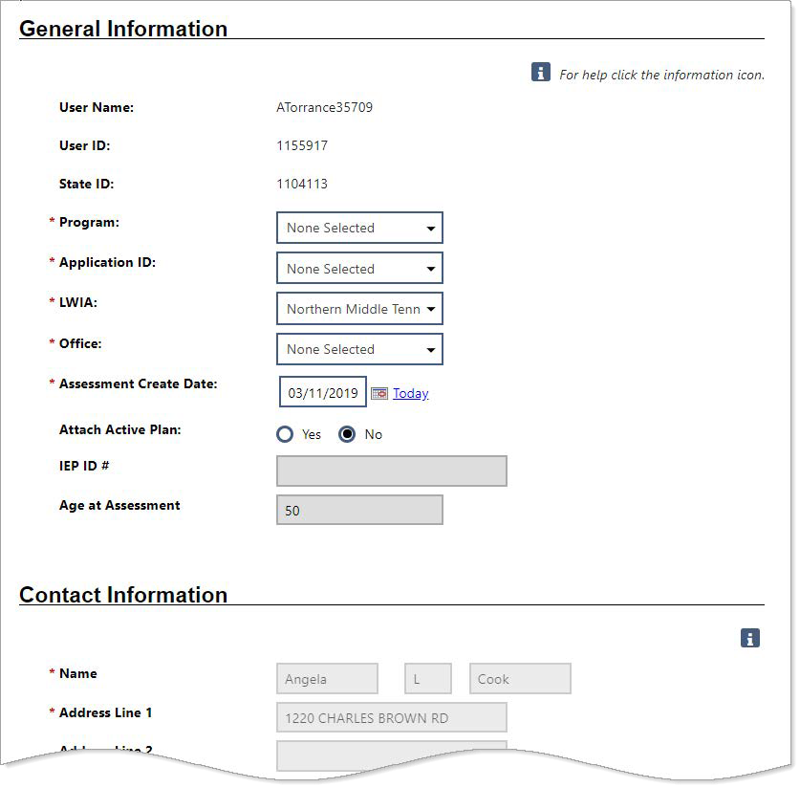
“Attach Active Plan” will almost always be “no” unless they have an active plan.
This is the date you conducted your initial assessment of the client

Objective Assessment Wizard - Page 1: General

- To begin creating the OAS:
- In the General Information section, select the Program for which you’re creating the OAS. The Application ID fills in automatically.
- Select your LWIA and Office affiliation.
- Enter the Assessment Create Date for the OAS.
- Select whether to attach an active Individual Employment Plan (IEP) to the OAS. If Yes, enter the plan ID (if only one exists, it populates automatically).
- In the Contact Information section, if necessary to add or change any information, click the Edit Contact Info link.
- In the Alternate Contact section, to add an alternate contact person, click the Click Here link.
- In the Staff section, if desired, enter a note for the assessment in the Overall Note text box.
- Click to save your edits and continue to the Expectation page (see figure below).

- To record the participant’s expectations in the OAS:

- In the Program Expectations section:
  - Indicate whether the individual seeks immediate employment.
  - Record desired services in the text box, for example, career counseling, work readiness, etc.
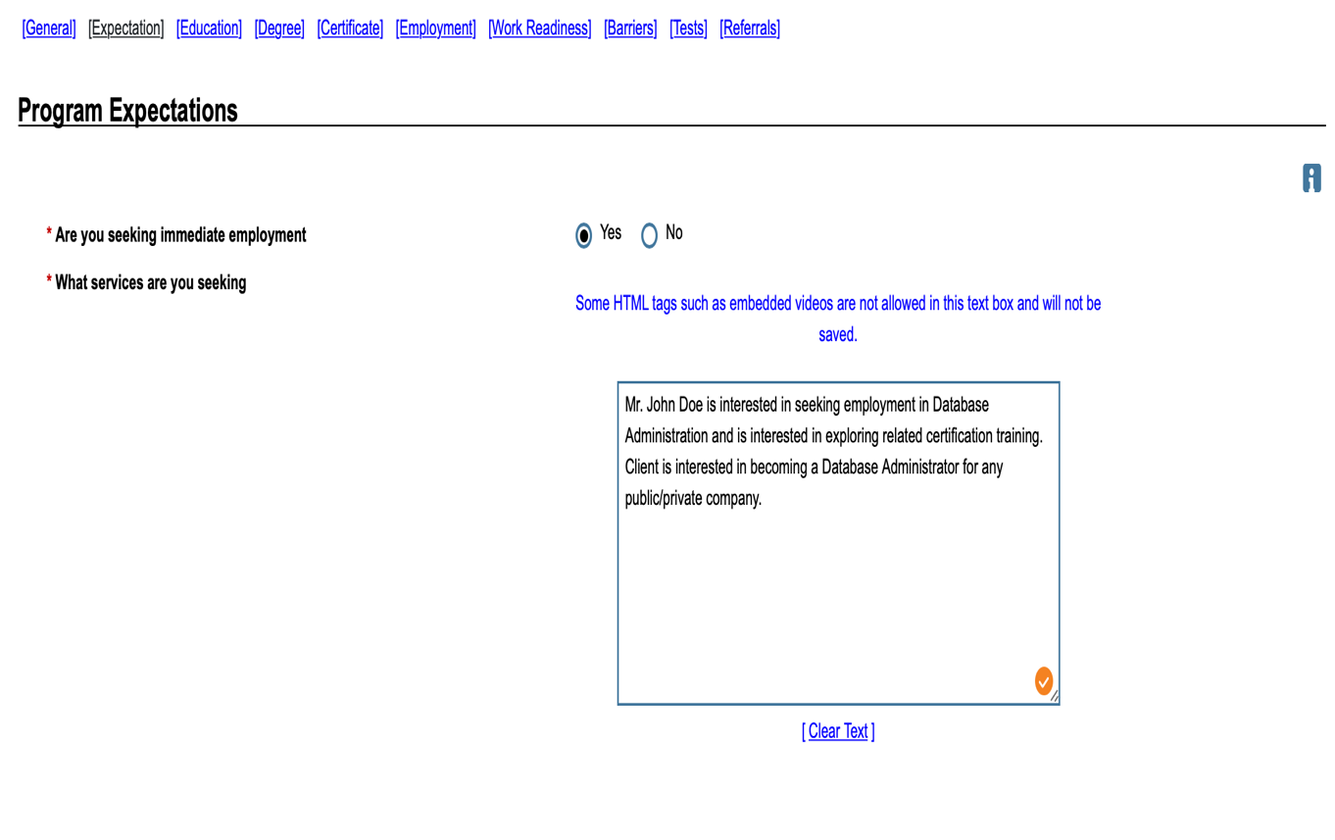
Objective Assessment Wizard - Page 2: Expectations
This is your place to write down what services the customer is requesting (i.e. career services, training, etc.). Are they looking for both survival and career jobs? Be specific!
- In the Employment Expectations section:
- For this tab refer to the information gathered from labor market research (currently through JobsEQ, Career Concourse, O’Net, etc.)
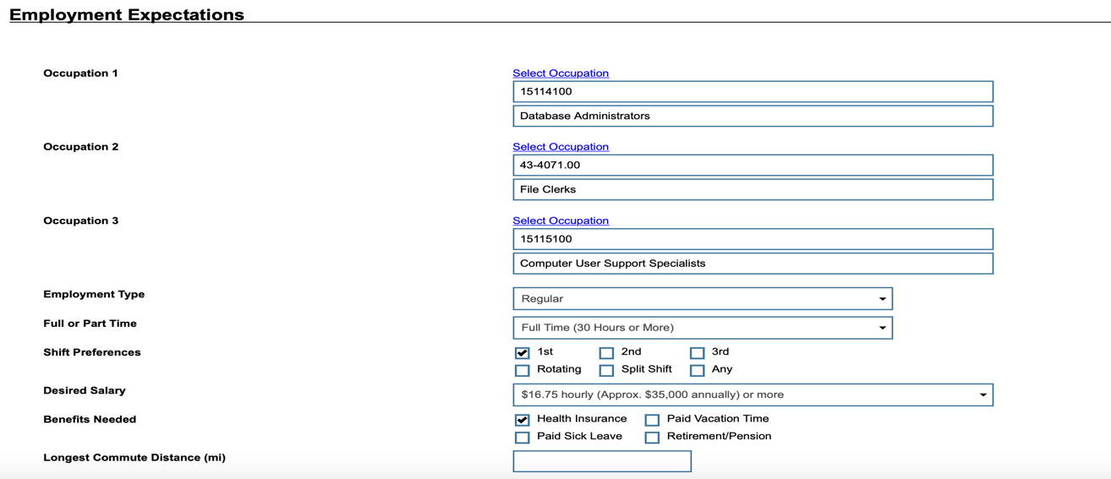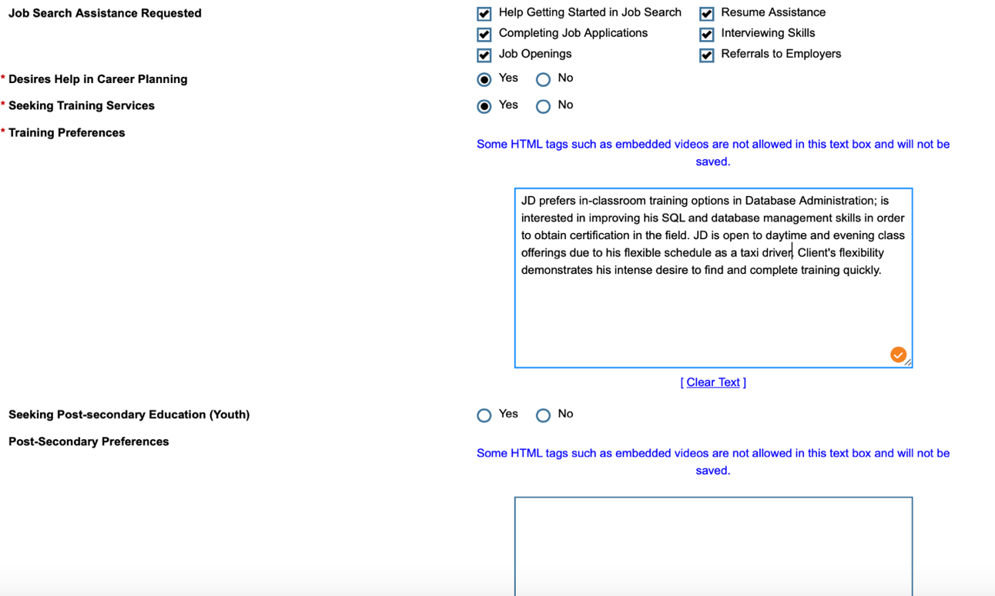
Note: Jobs EQ reports include information on the training and soft skills needed by employers. The client and ESS should review LMI and Jobs EQ report. The training identified should link to desired occupation identified and current in-demand certifications for those occupations. Ensure to include clients training needs for both vocational skills and soft skills. For example, Database Administrators: Technical skills – Oracle, SQL; Soft skills; Communication English – written and verbal; Certifications - mySQL

- Training Preferences: this is your spot to write about the customer’s training interests; what type of training? What type of platform and delivery? Schedule? Etc.
- Identify any job search assistance requested, and other requested career planning or training services and preferences, as appropriate.

- Specify desired job attributes, such as employment type, full or part time, shift preferences, desired salary, etc.
- Select up to three desired occupations. For details, see the topic “Select an Occupation.”

- Click to save your edits and continue to the Education page.

- To add education details to the OAS:
- In the Education History section:
  - Select the individual’s highest grade completed and current school status.
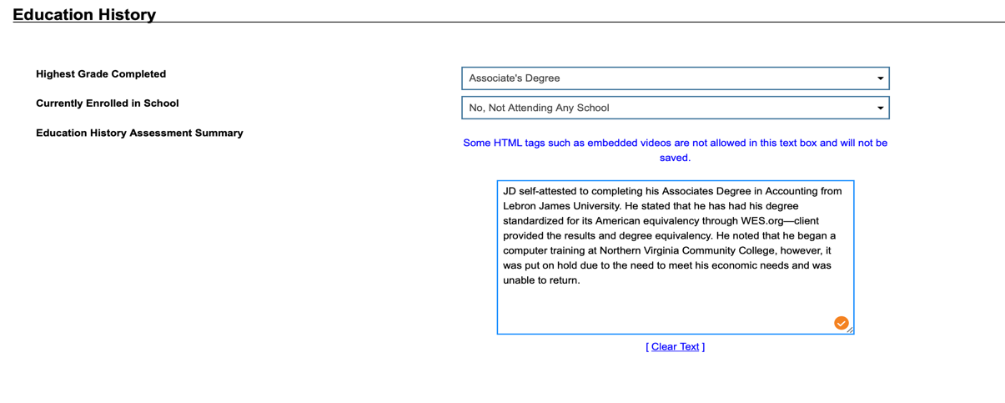
- Education Preferences: this is your spot to write about the customer’s educational history; what high school, university, trade-school have they attended?

- In the Basic Skills/Education Factors section below, identify their dropout status, areas of basic skills deficiency, primary language, need for financial aid, and other factors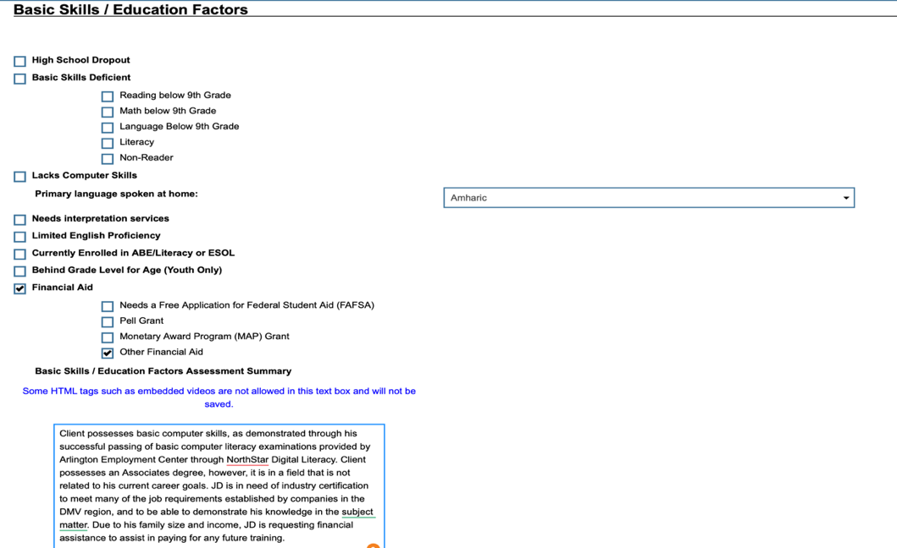
NOTE: This information is critical in determining goals in the IEP on employability skills (i.e computer literacy, proficiency in English, communication skills, etc.)
- Click to save your edits and continue to the Degree page.
- To add degree information to the OAS:

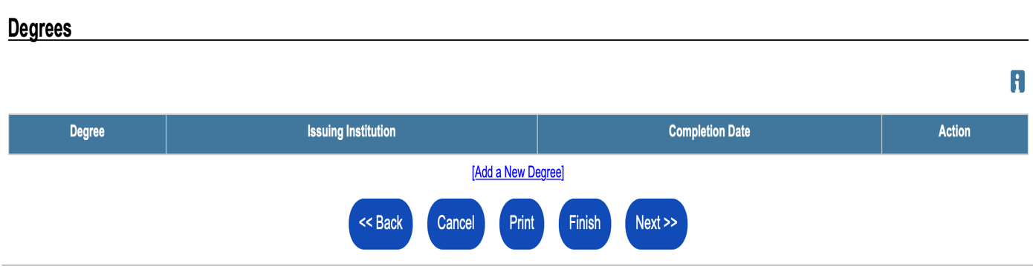
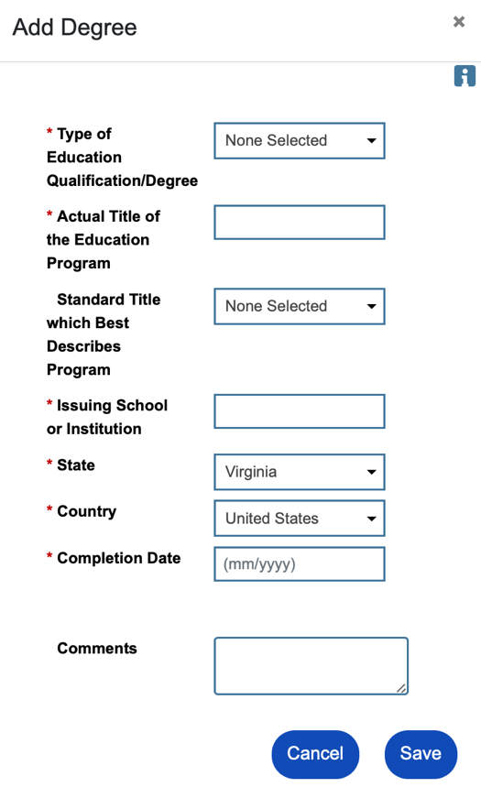
- To add a degree, click the Add a New Degree link.
- In the Add Degree pop-up box, complete the required details of the individual’s degree, then click Save.
Note: If any degree information was previously saved in the Background Wizard and/or Résumé Builder, it will be listed here. If an existing degree record needs to be changed, click the Edit link in the Action column.

- Click to save your edits and continue to the Certificate page.
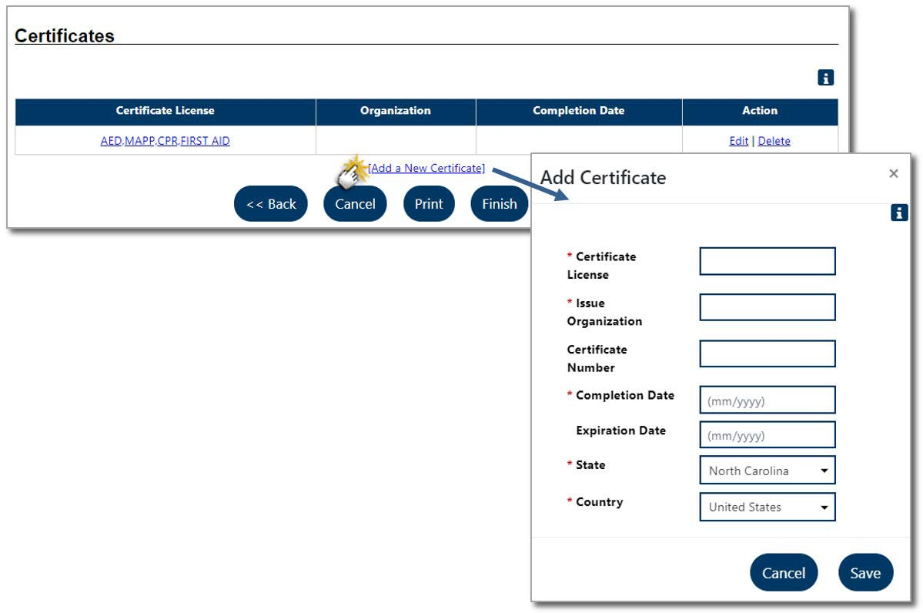
Objective Assessment Wizard - Page 5: Certificates

- To add certificate information to the OAS:
- To add a certificate, click the Add a New Certificate link.
- In the Add Certificate pop-up box, complete the required details of the individual’s certificate, then click Save.
- Click to save your edits and continue to the Work Readiness page.
- To record work readiness details in the OAS:
- Select items by clicking in the checkboxes as necessary.
- Enter comments as needed.
This page allows staff to identify what obstacles or issues the individual might face that will affect their work readiness.
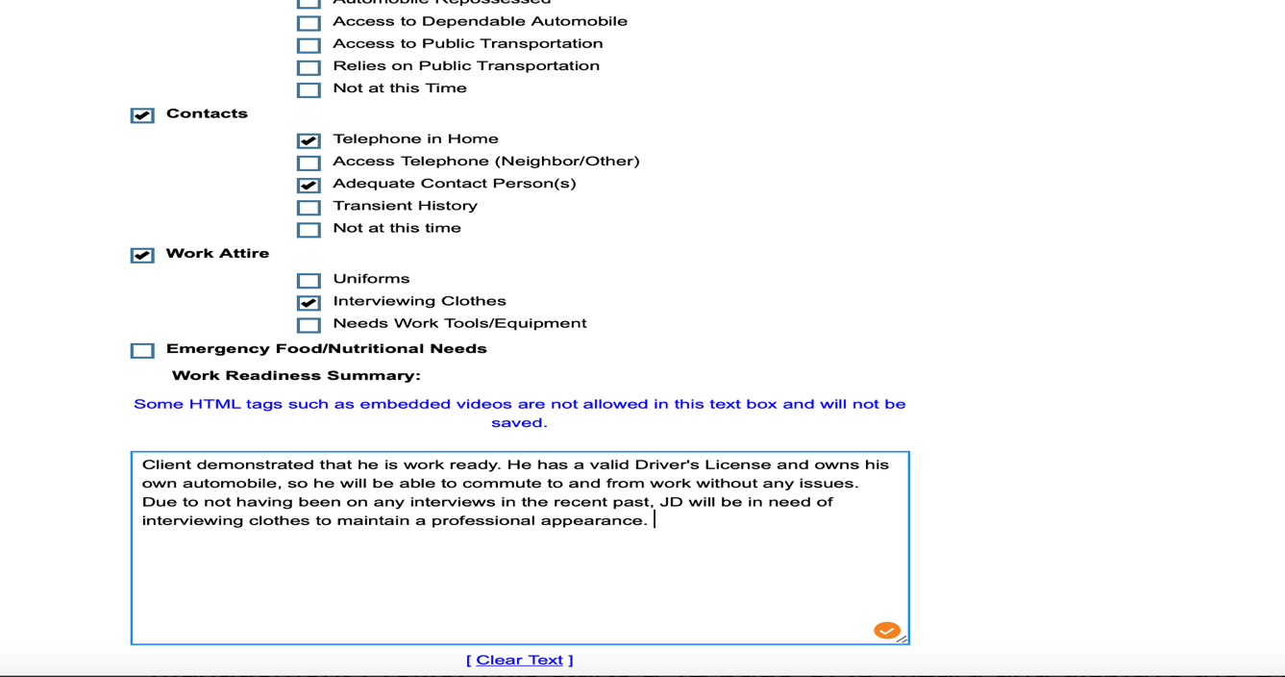
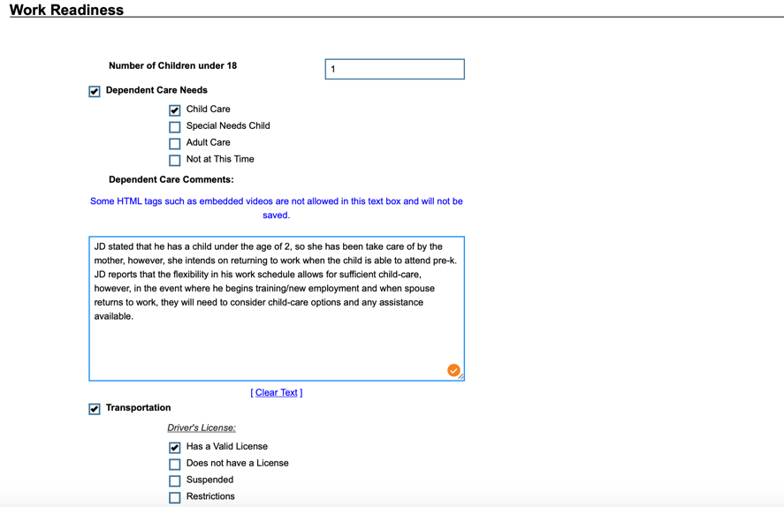
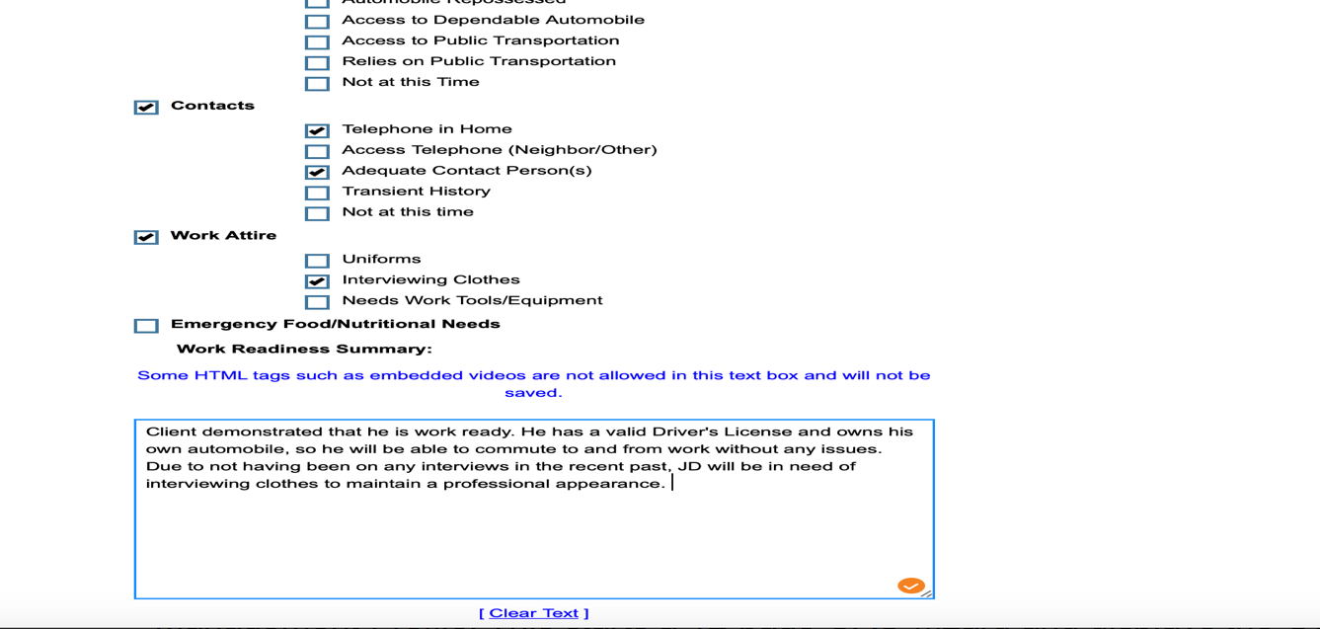
NOTE: Consider this information when developing employment goals in IEP. Also, consider this for providing access to supportive services with partners to further assist in achieving self-sufficiency. For example, if the customer needs interviewing clothes, then we could refer to Dress for Success. See Activity/Service Codes 180-193 for supportive services.

- Click to save your edits and continue to the Barriers page.

- To record barriers to employment in the OAS:
- Select statements that correctly characterize the individual’s health, behavior, and substance abuse information by clicking in the checkboxes as necessary.
- Enter comments as needed.
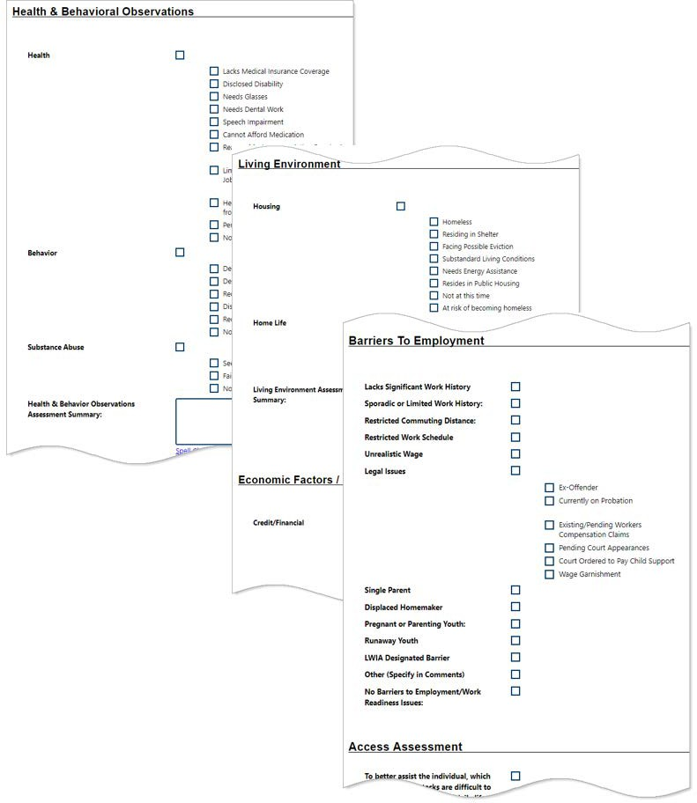
NOTE: Consider these factors when addressing any barriers to employment and well-being (self-sufficiency).

- Click to save your edits and continue to the Tests page (see figure below).
Occupational Factors, Other Assistance Received, Barriers to Employment, and Access Assessment.
Health & Behavioral Observations, Living Environment, Economic Factors/Financial, Vocational/
obstacles or issues the individual might face that will affect their employment/training. Sections include
The comprehensive Barriers page allows staff to identify—after observing the individual—certain

- To record test results in the OAS:
- Click the desired Click Here link to add, view, or edit any Basic Skills Assessment, WorkKeys® (if WorkKeys are part of your system), or Other Testing. A pop-up window will display for adding or editing existing assessment results, just as they are maintained in the Assessments tab of the individual’s Case Management Profile (as shown above for a WorkKeys assessment).
- Enter any comments in the box to summarize and provide any details for selected test.

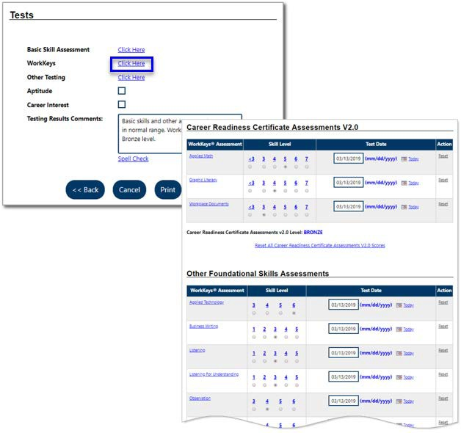
Objective Assessment Wizard – Page 11: Tests
- Click to save your edits and continue to the Referrals page (see figure below).

In certain circumstances, a referral may be made as the last step related to the OAS.

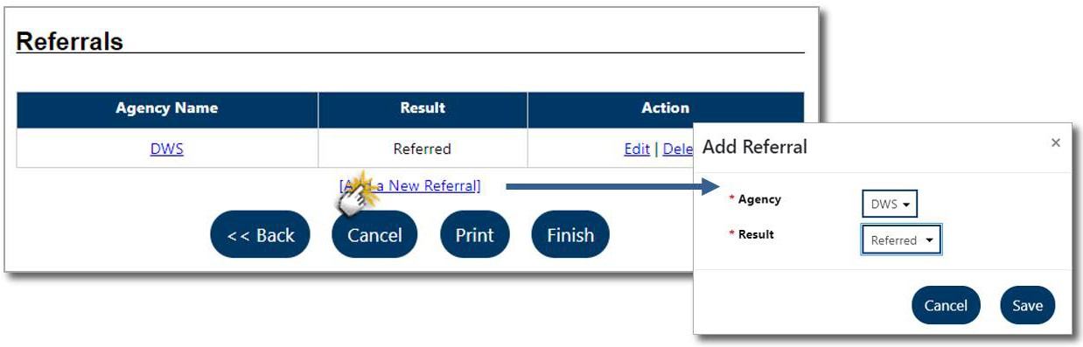
Objective Assessment Wizard – Page 12: Referrals

- To add a referral to the OAS:
- Click the Add a New Referral link.
- Complete the fields on the Add Referral pop-up window and click Save.
- Click to complete the OAS.

Individual Employment Plan/Service Strategy (IEP/SS)

The IEP is an ongoing strategy jointly developed by the participant and case manager that identifies the participant's employment Goals, the appropriate achievement Objectives, and the appropriate combination of Services for the participant to achieve the employment Goals.

Designing an ISS or IEP (source Virginia WIOA Title I Case Manager Learning and Resource Manual PY 2019 Edition)

WIOA Title I programs offer a diverse range of services to participants. However, funding levels per participant are often capped, and other services cannot be provided with the federal program funding. By becoming familiar with other programs and community resources, you can effectively link your participants to these resources. This may help increase your participants’ stability and increase their ability to complete training programs or successfully start a new career.

In WIOA, the employment plan is referred to as an Individual Service Strategy (ISS) for youth or Individual Employment Plan (IEP) for adults and dislocated workers. The WIOA ISS or IEP as an agreement between the participant and case manager about how the participant will progress through benchmarks on the way to meeting his or her goals. The ISS and IEP are most effective when tailored to the specific needs of the participant, referenced often, and updated regularly to chart and reflect any changes. The case manager needs to understand how to work with participants to develop an ISS or IEP that sets specific, measurable, obtainable goals and provides reasonable time frames for achieving them.
- It is suggested that the ISS or IEP include the following content:
- Goals: What the participant wants to achieve, generally related to employment, such as obtaining a particular type of job.
- Objectives: The specific steps the participant will take to realize a goal.
- Services: The services the customer will need in order to meet objectives.
- The case manager should use the content from the goals, objectives, and services sections of the IEP as a road map to help the participant achieve employment. When planning a course of action for an IEP, the case manager should consider the following:
- The customer’s vision: Based on the participant’s current situation, where he or she would like to be after receiving education, training, or other services.
- Next steps: The actions the participant needs to take at any point in the program or service strategy, which requires updating as the participant completes steps.
- Milestones: The completion of a step or achievement of an objective in the plan that is specific, measurable, and attainable within a designated time frame.
Four Tabs of the Individual Employment Plan/Service Strategy

The tabs must be completed in order and contain the following information:
  - Plan Tab - contains general information about the participant, the program they are enrolled in, and plan dates.

  - Goal Tab - allows staff to establish or edit Goals for an IEP/SS. The primary goal for Adult/Dislocated Worker customers is unsubsidized employment, and all adult/dislocated workers must have an employment goal. The Goals for Youth are unsubsidized employment and/or post- secondary education (which includes advanced training).
      - There are 3 categories of Goals for Adult / DW clients – Employment and Training, Schooling
      - IEP at the minimum to have goals in the following 5 areas, as applicable. ESS and client to determine more goals as needed.
        - Employment Goal 1 to focus on unsubsidized employment
        - Employment Goal 2 to address work readiness issues noted in OAS
        - Employment Goal 3 to address any barriers to employment noted in OAS
        - Training Goal 1 to address certification / technical skills identified in OAS
        - Training Goal 2 to address soft skills noted in OAS

  - Objectives Tab - allows staff to add Objectives associated with IEP/SS Goals. Staff can select Pre-Defined Objectives or create a New Objective. Objectives will outline “how” a goal will be achieved.

  - Service Tab - displays all Services provided for the individual, including Universal (WP), WIOA and Generic. All Services provided should relate back to the IEP Objectives and Goals.

Note: A participant can only have one IEP open at a time. The IEP itself must be created first (Plan tab), followed by the plan's Goals. A goal must be created before Objectives for that goal can be recorded.

Creating a New Individual Employment Plan/Service Strategy (IEP/SS)
- To create an Individual Employment Plan/Service Strategy (IEP/SS):
- Click the Create Individual Employment Plan/Service Strategy button on the Plan tab of the Case Management Profile.
Click here to create employment and career goals, achievement objectives, and where the appropriate services are recorded.
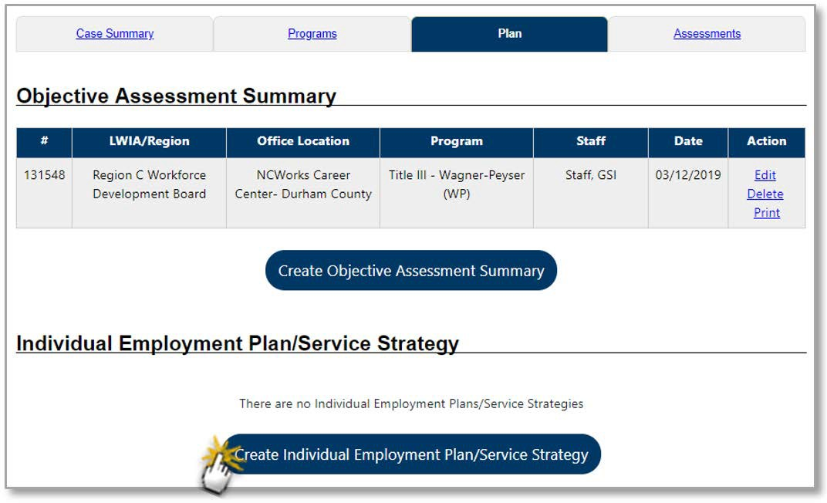
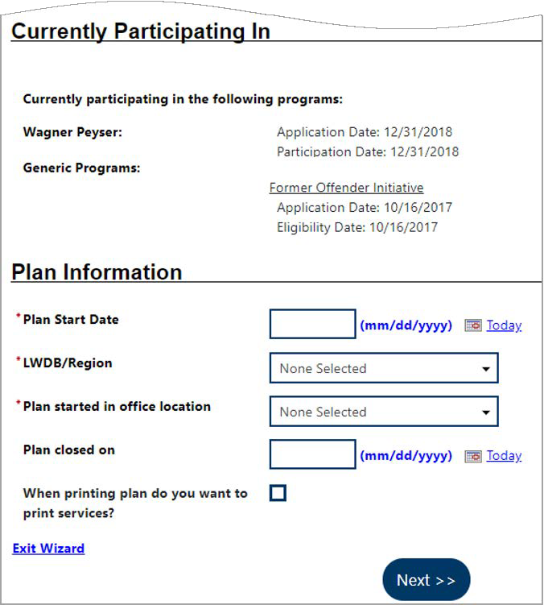
Plan Tab of Case Management Profile

Click here to create employment and career goals, achievement objectives, and where the appropriate services are recorded.
The start date is usually when the customer beings receiving services.
- In the Plan Information section, complete the required fields, then click to save and continue to the Goals tab. Any existing goals are listed in the IEP/SS Goals section.

- To add a new goal to the IEP:

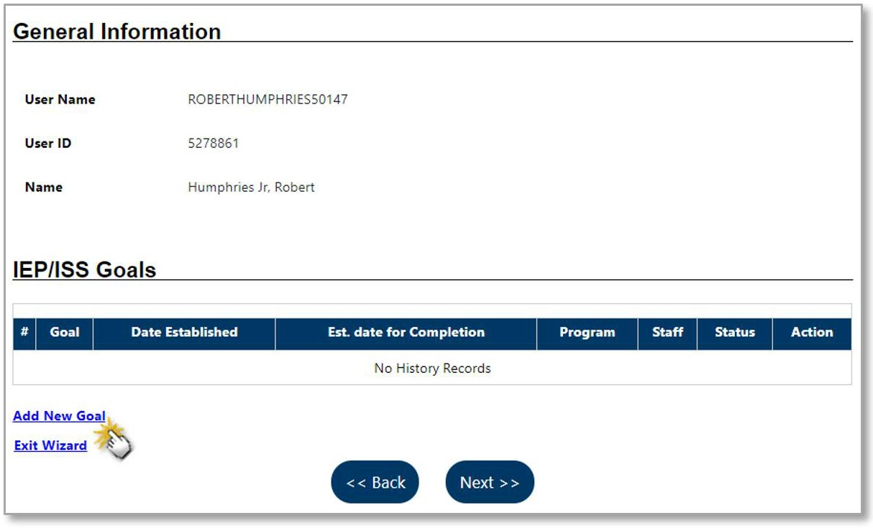
Create IEP – Add New Goal Page

- Click the Add New Goal link. The Add New Goal page displays.
Note: Goals must be added to the IEP before Objectives since objectives are linked to them.

Include 3-5 types of goals (depending on skill level/need);
- Employment – Long-term, Unsubsidized
- Employment – work readiness areas
- Employment – to overcome barriers
- Training – technical / hard skills
- Training - Soft-skills

Goals & Objectives
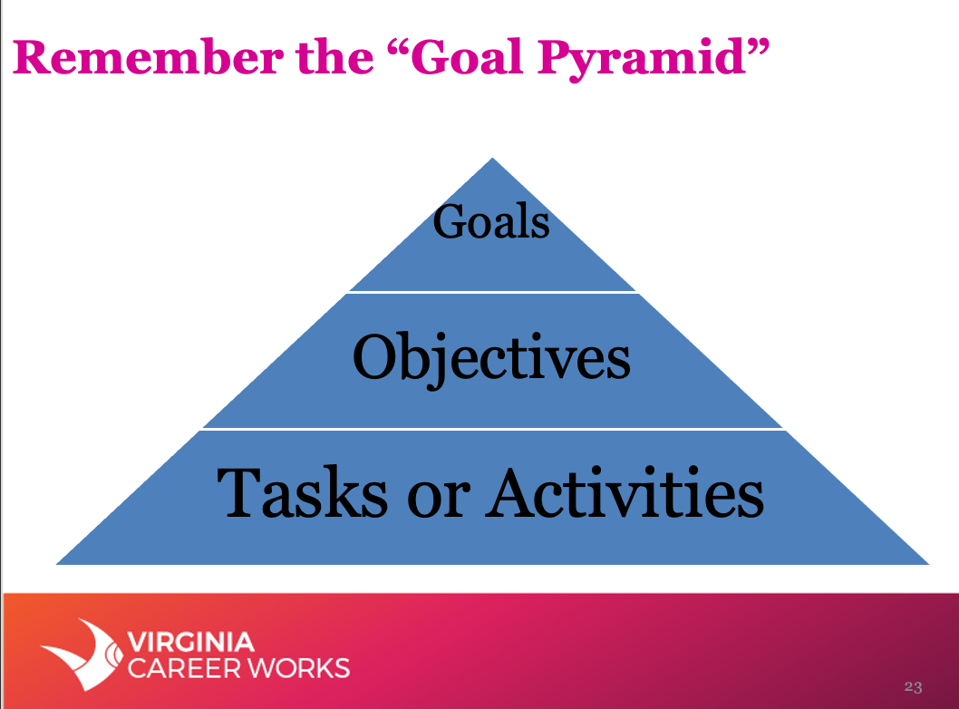
Some major differences between Goals and Objectives:
Alignment and order: Goals are set to achieve the mission of individual, while objectives are set for the accomplishment of goals. Goals are thus higher in order than objectives.
Scope: Goals are broad intentions and are often incapable of being measured in quantifiable units. Objectives are narrower than goals and are described in terms of specific tasks.
Specificity: Goals are general statements of what is to be achieved. They do not specify the tasks that need to be performed to accomplish them. Objectives, on the other hand, are specific actions one takes within a certain timeframe.
Tangibility: Goals can be intangible and non-measurable, but objectives are defined in terms of tangible targets. For example, the goal to “provide excellent customer service” is intangible, but the objective to “reduce customer wait time to one minute” is tangible and helps in achieving the main goal.
Timeframe: Goals are set to be achieved over a long period, while objectives are meant for a shorter time frame. A goal is usually divided into several objectives spread over multiple time frames.

These are the actions taken to reach the individual milestones (Objectives) that collectively lead to the end Goal.

Objectives are the milestones along the path to the Goal.

Goals are the destination your Road Map (IEP).

S.M.A.R.T Goal Planning

To assist both the customer and Employment Services Specialist in establishing a plan with clear goals and objectives, you can use a framework called S.M.A.R.T goal planning. Goal setting is a helpful way to build the career you want. By setting objectives and creating a clear roadmap for how the customer will reach their intended target, they can decide how to apply their time and resources to make progress.
SMART is an acronym that stands for Specific, Measurable, Achievable, Relevant and Time-based. To avoid difficult to achieve goals (due to vagueness, aggressiveness, etc.), each element of the SMART framework works together to create a goal that is carefully planned, clear and trackable.
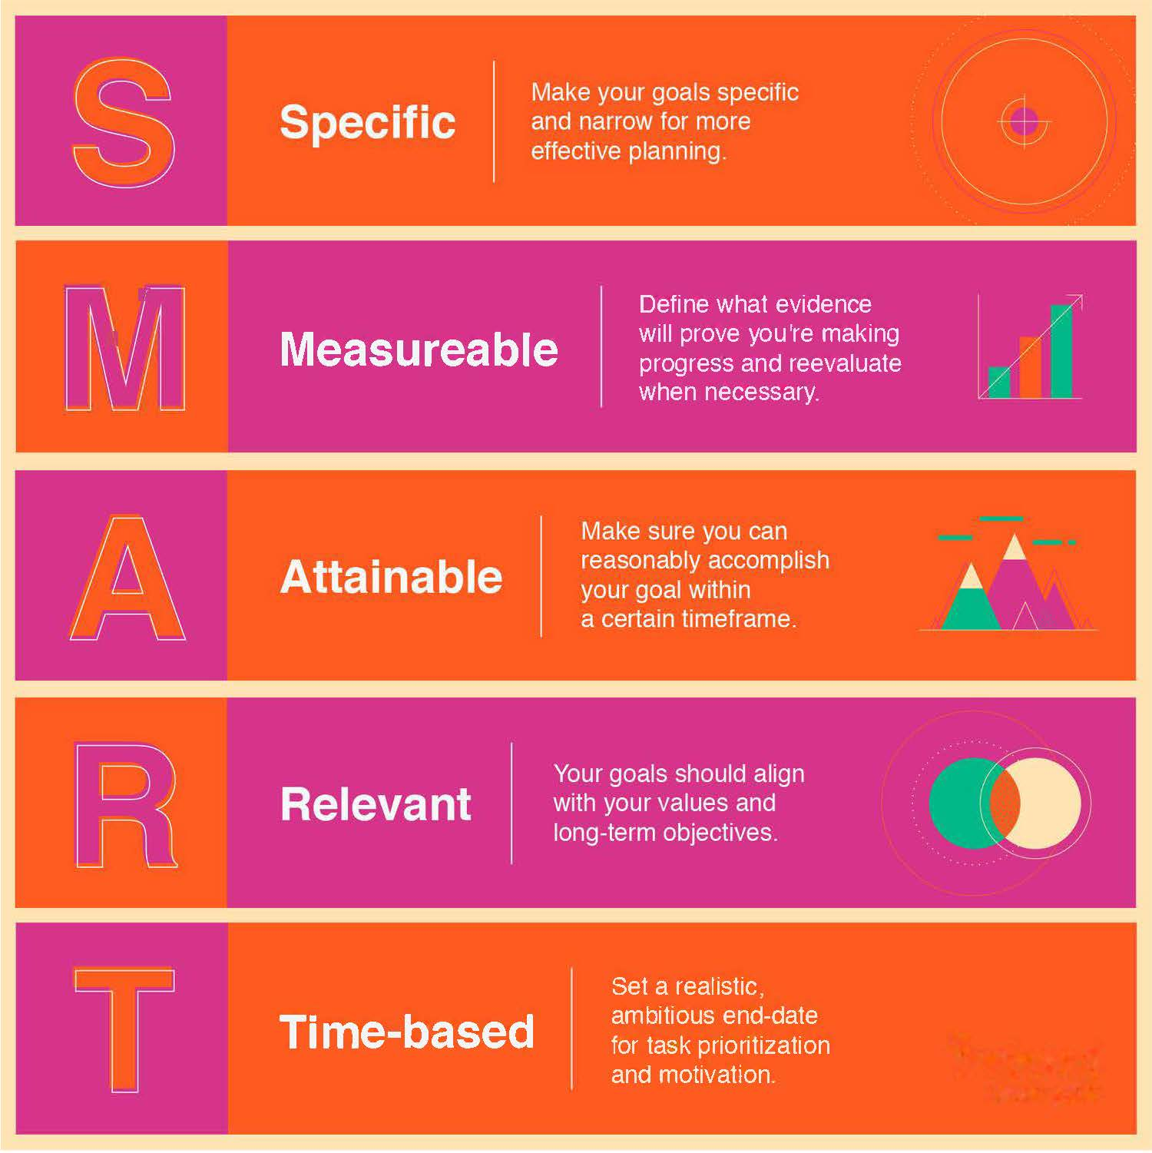
- Scenario A
“I have extensive experience in project management and want to get a PMP Certification so I can qualify for the Project Manager positions within my company or any others in a commutable distance. I have seen various PM openings on our careers web-site and Indeed but they all require a PMP”
- Goal(s): Employment, Training
  - Employment: Obtain employment as a Project Manager after earning the PMP certification.
  - Training: Earn PMP Certification within one month of completing PMP training.
  - Training: Improve Computer Literacy skills related to MS Office; Excel, Project.

- Objective(s):
  - Employment: Client will attend Job Search Basics and Employability Skills Workshops on 10/28 and 10/29 to improve soft skills and marketability.
  - Employment: While in training, the client will create/update resume with relevant qualifications and draft preliminary cover letter.
  - Employment: Upon completing training, the client will apply to 5 Project Manager positions per week.
  - Training: Enroll and complete PMP Certification Training by 11/30/2020; according to Jobs EQ Reporting, over 1,000 positions in the region require PMP certification.
  - Training: Enroll and complete AEC Advanced Computer Class by 12/30/2020; according to JobsEQ, there was a reported 3,500 open jobs in demand for these hard skills.
  - Training: Complete at least 2 free PMP prep courses per month through Lynda, Metrix Learning, Alison.
  - Training: Register and take PMP Certification Exam no later than 1 month after training completion.

- Sample Activities/Services:
  - 153 – Job Search Assistance/Placement
  - 205 – Develop Service Strategies
  - 227 – Computer Literacy
  - 300 – Occupational Skills Training - Approved Provider
- Scenario B
“I have been living in the United States for the past 10 years after moving from Venus. I have been working as a Food Service Worker for the entire time but have been laid-off since March due to the Covid-19 pandemic. I’ve had several interviews by networking, but I believe I am not getting hired because of my limited English and lack of post high school education. I’d like to continue in Food Services but in a higher paying role with more responsibilities. I would like to improve my skills but I am at risk of losing my Housing Grant due to lack of work and income.”

- Goal(s): Employment, Training
  - Employment (Long-term): Obtain employment as a Food Service Manager after earning the ServSafe Food Manager certification.
  - Employment (Immediate-Term): Obtain immediate survival position in Culinary field as Food Service Worker, Prep-Cook for at least 30 hours per week.
  - Training: Earn Food Manager Certification within one month of completing La Cocina VA training.
  - Training: Improve English Literacy skills to improve communication skills and marketability.
  - Training: Improve Computer Literacy skills related to Basic Access, Internet and MS Word.

- Objective(s):
  - Employment: Client will attend Job Search Basics and Employability Skills Workshops on 10/28 and 10/29 to improve soft skills and marketability.
  - Employment: While in training, the client will create/update resume with relevant qualifications and draft preliminary cover letter.
  - Employment: The client will apply to 5 Food Service Worker, Prep-Cook positions per week.
  - Employment: By the end of the week (10/23/20), the client will contact DHS Public Assistance (referred to Darth Maul) for support with rental assistance and follow-up information about the Housing Grant’s work and training requirements.
  - Training: Enroll in Food Manager Certification Training by 12/30/2020; according to Jobs EQ Reporting, RTI indicates an increased demand for the ServSafe.
  - Training: Enroll and complete AEC Basic Computer Class by 11/01/2020
  - Training: Enroll and complete 1st session of APS REEP Intensive ESL Program by 1/15/2021
  - Training: Register and take ServSafe Food Manager Certification Exam no later than 1 month after training completion.

- Sample Activities/Services:
  - 153 – Job Search Assistance/Placement
  - 184 – Supportive Services- Housing
  - 205 – Develop Service Strategies
  - 222 – English as a Second Language
  - 227 – Computer Literacy
  - 300 – Occupational Skills Training - Approved Provider
- Scenario C
“I got pregnant and was forced to drop out of High School in my last year of school. For the first year, I stayed at home to take care of my child, but since then I have been working for the 18 months. I have been working 30-35 hours per week as a self-employed Companion until recently—my only client passed away due to Covid-19. I have been looking for healthcare, personal support positions through my phone for the past two months but have not heard anything. Most job openings require a High School Diploma and CPR as basic requirements, as well as, either a HHA, PCA, or CNA certification. I contacted Global Educational Institute as they offer these trainings, however, a HS Diploma and/or GED is required for the certification exams. I need a job now to pay all my bills/utilities, as well as, to pay for child-care since I am a single mother. However, I would still like to work as a Nursing Assistant in the future and would consider training while working.”

- Goal(s): Employment, Training, Schooling
  - Employment (Long-term): Obtain employment as a Certified Nursing Assistant in Nursing Facility after earning the CNA Certification.
  - Employment (Immediate-Term): Obtain immediate survival position (PT or FT) in Retail/Hospitality field as Customer Service Rep, Food Service Worker, Crew prior to starting of any type of schooling.
  - Schooling: Earn Diploma for High School Equivalency (GED) prior to start of any type of CNA training.
  - Training: Earn Certified Nursing Assistant Certification within one month of completing CNA training.

- Objective(s):
  - Employment: Client will attend Job Search Basics and Employability Skills Workshops on 10/28 and 10/29 to improve work-readiness skills and marketability.
  - Employment: The client will create/update resume shell with relevant qualifications by next bi-weekly meeting 11/02/2020.
  - Employment: The client will apply to 5 survival positions (PT or FT) in Retail/Hospitality field as Customer Service Rep, Food Service Worker, Crew positions per week.
  - Employment: The client will contact DHS Public Assistance (referred to Luke Skywalker) for support with child-care assistance and follow-up information about the County’s Child-care Initiative by 10/30/2020.
  - Schooling: Enroll and complete APS Community Learning Adult GED Program by 12/31/2020; according to Jobs EQ Reporting of data reflecting online job postings for the 180-day period ending 10/21/2020, 57% of the 2821 openings required a High School Diploma and/or equivalent (GED).
  - Schooling: Register and take GED exam no later than 1 month after completing prep course.
  - Training: Enroll in CNA Certification Training by 01/31/2021; according to Jobs EQ Reporting of data reflecting online job postings for the 180-day period ending 10/21/2020, 35% of the 2821 openings required the CNA Certification and 22% required CPR/First Aid/BLS Certification.
  - Training: Register and take CNA Certification exam no later than 1 month after completing training program.

- Note that as you progress through the plan, objectives will be closed, and new ones created. For example, once the client is in training, a new employment objective can be created to address the job search/prep for CNA positions.

- Sample Activities/Services:
  - 153 – Job Search Assistance/Placement
  - 180 – Supportive Services- Childcare & Dependent Care
  - 205 – Develop Service Strategies
  - 214 – Adult Literacy, Basic Skills or GED Preparation
  - 300 – Occupational Skills Training - Approved Provider

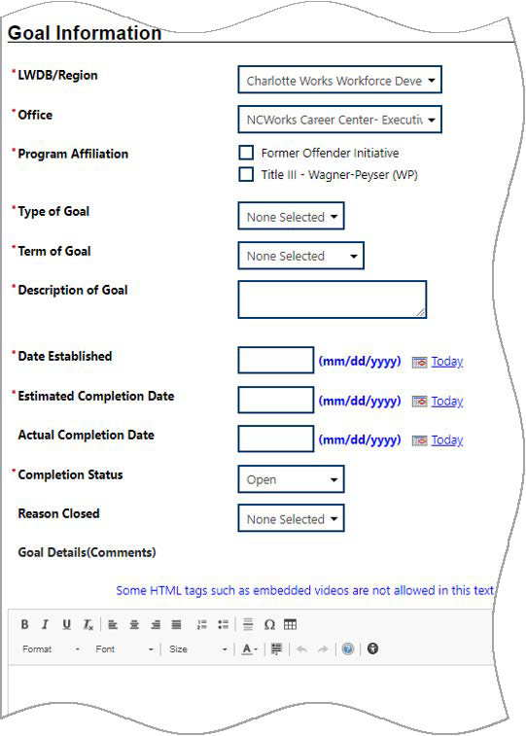
Write down any specific details about the goal; try answering—what is the goal? Why and how will this help the client? What are the steps to achieve the goal? Will the customer need any additional supports?

Goals should follow the SMART approach–please refer to the ppt by VCCS where they expanded on this and provided an example of this. I couldn’t find the ppt in the practitioners’ corner. If possible insert an example here of a SMART goal.

Specific -
Measurable
Achievable
Realistic
Timebound

Type of goal: Employment, Training, Schooling
Note: Leave the Completion Status set to Open and Actual Completion Date blank. When closing the goal, you will enter the Actual Completion Date, select Closed, and then indicate the Reason Closed.

Make sure you select the correct program affiliation; Title I – Workforce Development (WIOA)
Term of goal: Immediate, Short term, Long term
Write a short description that will appear in the main “Goals” screen.

- In the Goal Information section, select a LWDB/Region and Office.
- Check Program Affiliation(s).
- Select a Type of Goal: Employment, Training, or Schooling.
- Select the Term of Goal: Short Term, Long Term, Intermediate Term.
- Enter a Description of Goal.
- Enter the Date Established for the goal.
- Enter the Estimated Completion Date for the goal.
- Enter any additional information in the Goal Details textbox.

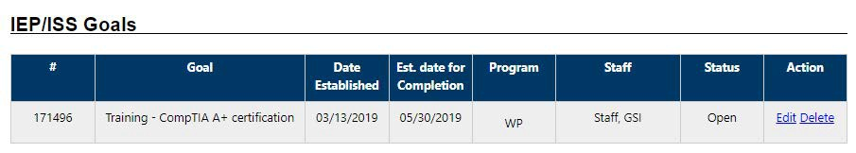
- Click Save. The Goals tab redisplays with the added goal along with links to Edit or Delete (see figure below).

Completed Goals Tab

- Repeat this procedure for as many goals as needed. Remember to target those 4 types.
- Click to proceed to the Objectives tab, where you add objectives that support the goal, either pre-defined (by the affiliated program) or by creating new ones.

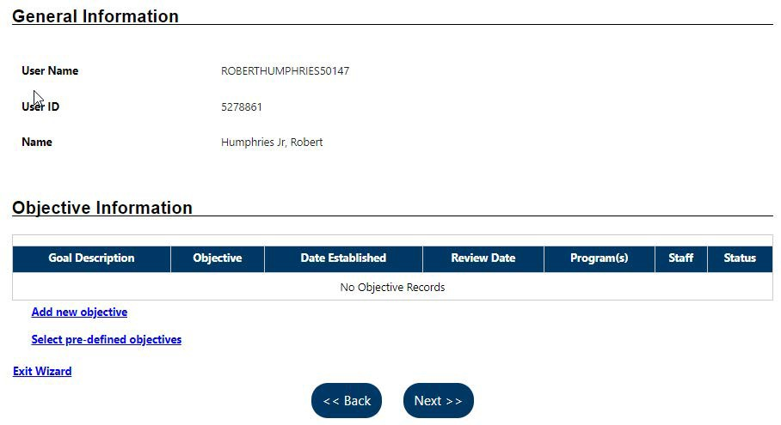
Create IEP – Objectives Tab
- To add a new objective to the IEP:
- Click the Add new objective link to enter a related objective for the individual. The Add New Objective displays.
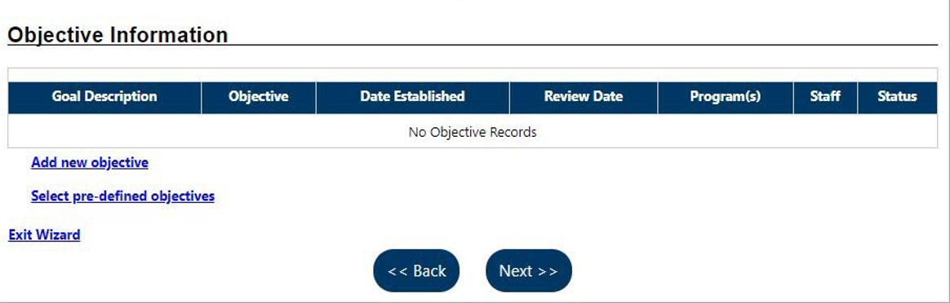
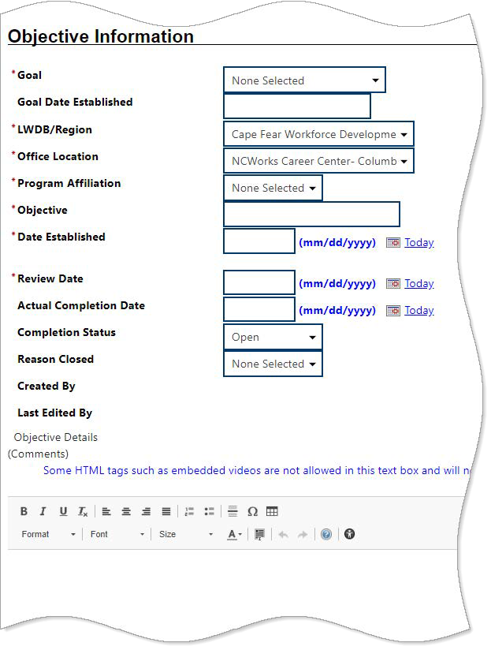
Note: Leave the Actual Completion Date blank and Completion Status set to Open. When closing the objective, you will supply the Actual Completion Date, select Closed, and then indicate the Reason Closed.

The Review Date defaults to 45 days after Established date; ideally the customer and staff are reviewing these on a weekly/bi-weekly basis depending on level of activity.
Name your objective; this will appear in the main “Objectives” screen.
Choose the goal you created in the last tab to tie in the objective.
Create IEP – Add New Objective Page
Write down any specific details about the objective and how it ties into the specific goal; try answering—what is the goal and how is this activity (objective) going to help me reach that goal? How will this impact customer’s progress? Will the customer need any additional supports? Etc.

- Select the Goal to be associated with this objective.
- Enter the date the goal was defined in the Goal Date Established field (defaults to today).
- Select the LWDB/Region, Office Location, and Program Affiliation.
- Name the Objective, which is an activity that will serve to achieve the associated goal.
- Enter the Date Established for the objective and the Review Date on which progress should be evaluated.
- Enter any additional information in the Objective Details textbox.
- Click Save. The Objectives tab redisplays with the added objective along with links to Edit or Delete (see figure below).
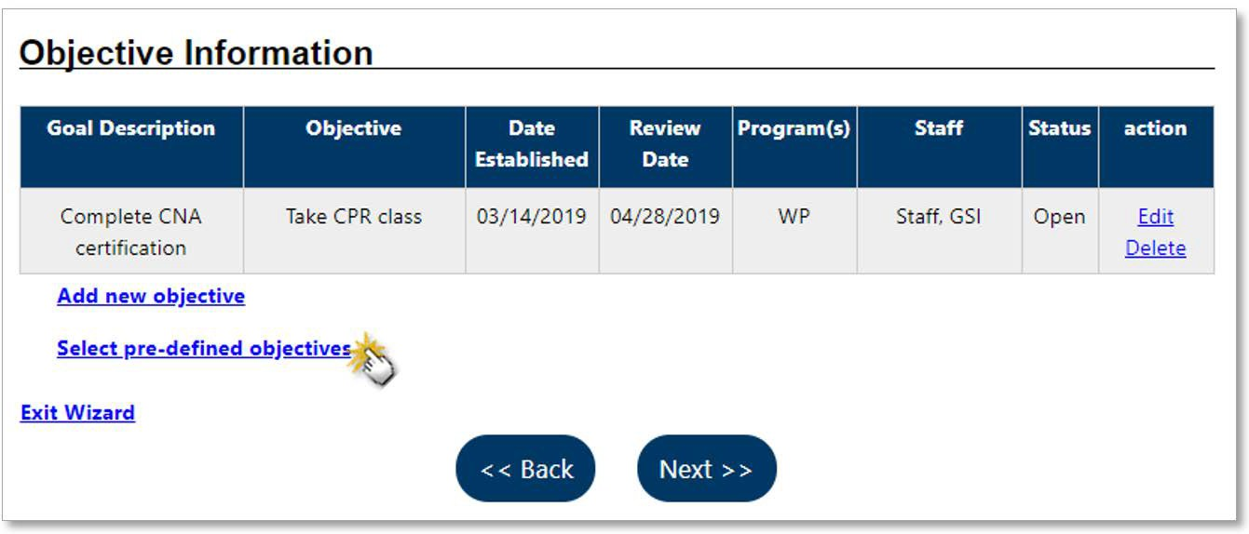
Note: Each goal that you created should have at least 1 objective, but there may be more than 1 objective needed per any one goal.
Instead of defining an objective in a free-form fashion, pre-defined objectives are available for selection based on the program affiliated with the goal.

Completed Objectives Tab

- Repeat this procedure for as many objectives as desired.
- Click to proceed to the Services tab or add pre-defined objectives.

- To add a pre-defined objective to the IEP:
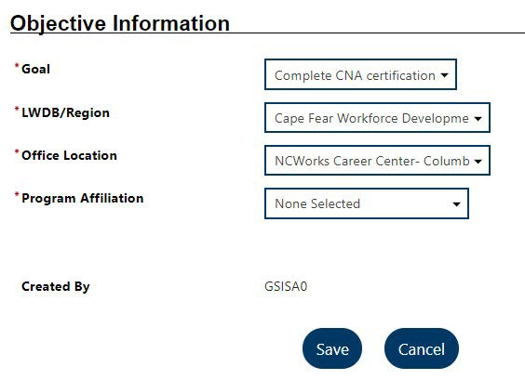
- Click the Select pre-defined objectives link (see figure above). The Add Pre-defined Objectives page displays.
Add Pre-defined Objectives Page
- Select the Goal for the objective(s).
- Select the LWDB/Region and Office Location.
- Select the Program Affiliation for the objective. The page will refresh after a few seconds with the list of pre-defined objectives for the program (see figure below).
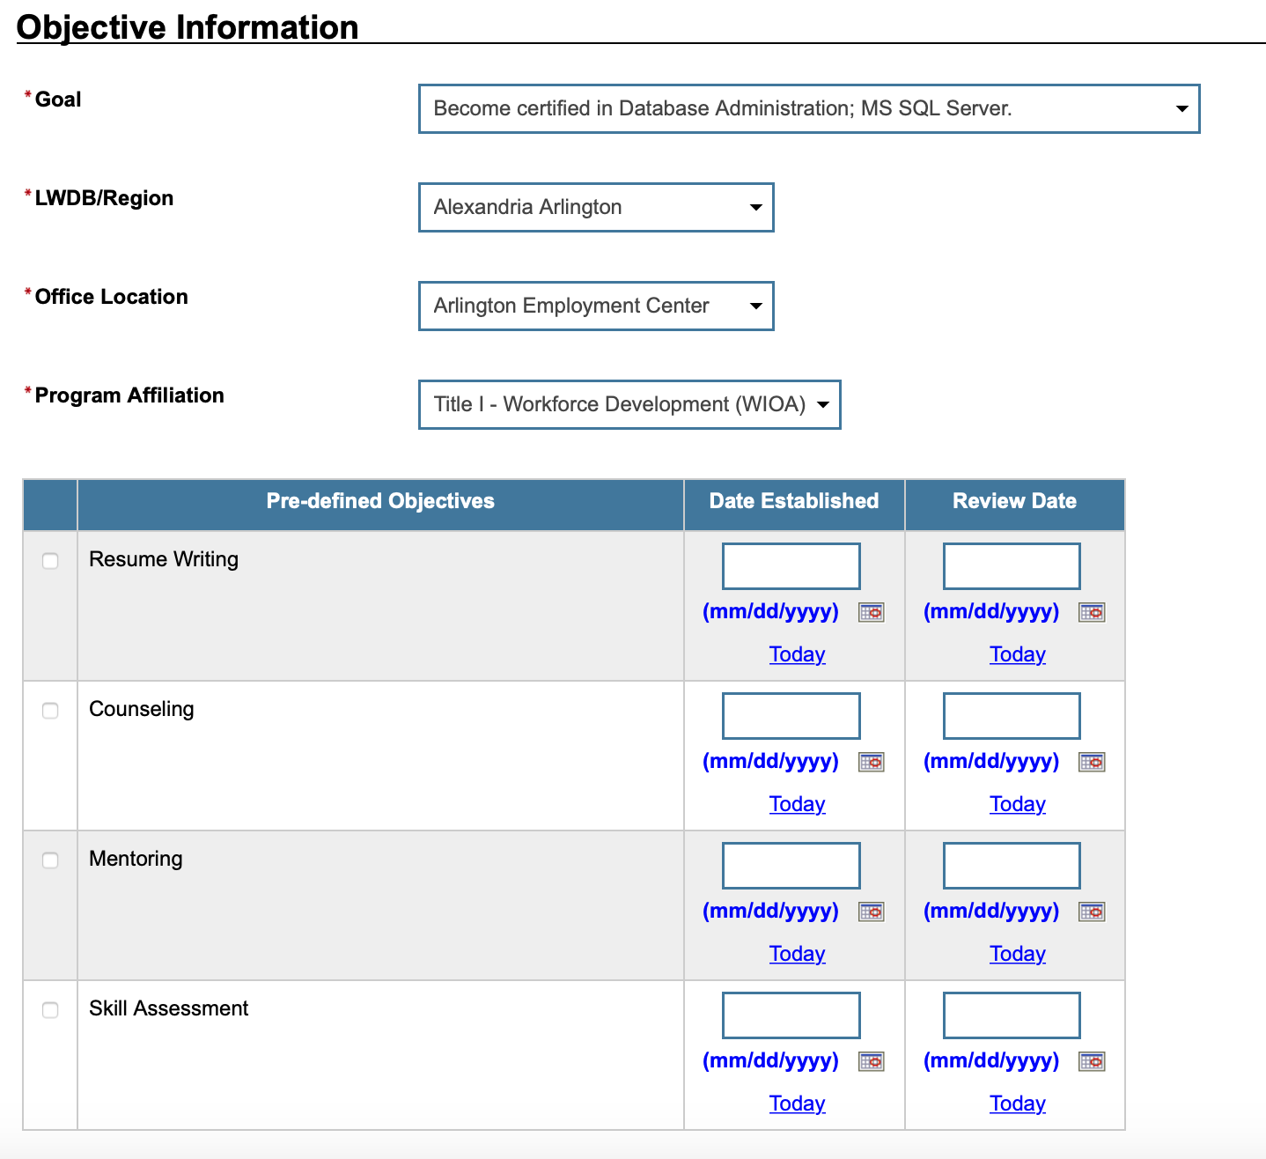
Choose the goal you created in the last tab to tie in the objective.
Click here to add defined objective.
Note: The objective established date must be greater than the goal established date and the review date defaults to 45 days after the established date.
Refreshed Pre-defined Objective Page

- Click the checkbox in the left column for each objective to add to the individual’s program goal.
- Enter the Date Established for each objective and the Review Date on which progress should be evaluated.
- Click Save. The Objectives tab redisplays with the added objective along with links to Edit or Delete (see figure on previous page).
- Click to proceed to the Services tab to review.

Note: If services or activities have been provided via the Programs tab, they will display on the IEP Services tab in view-only mode and cannot be modified from within the IEP.
- Click to complete the IEP/SS plan. The Plan tab of Case Management Profile redisplays with the IEP listed.

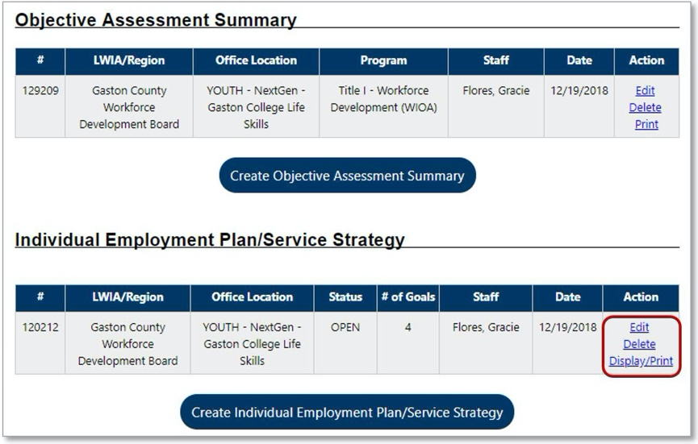
Plan Tab of Case Management Profile with Summary and Plan

Working with Existing IEP Plans
- To view and/or print the entire plan, including its Goals, Objectives, and Services:
- Click the Display/Print link in the Action column (see figure above).
- In the Plan Information section, click the checkbox if you wish to print the services listing.
- Check to include Applicant and/or Staff Signatures, if desired (must have a signature app installed).
- Click Print at the bottom of the page. A PDF version is generated and displays in a pop-up window. From there, you can download or print the file.

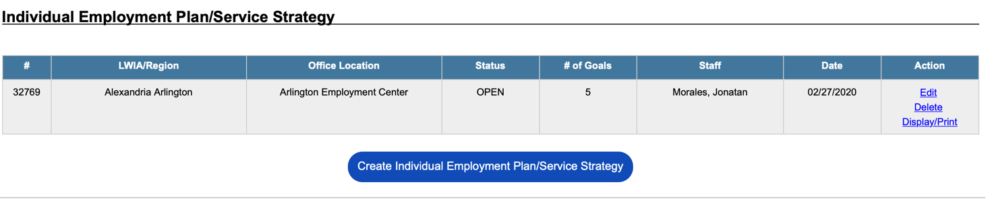

- To close Objectives or Goals:
- Click the Edit link in the Action column (see figure above). The Plan tab of the IEP displays.
- Click the Objectives or Goals tab, as appropriate.
- Click the desired Edit link.
- Enter the Actual Completion Date, set the Completion Status to Closed, and then select the
Reason Closed (Successful or Unsuccessful).
- Click Save. Repeat as needed.

Note: Remember, you must work from the “bottom up” when closing parts of a plan: Objectives first, then their associated Goals. All Objectives and Goals must be closed before the plan itself can be closed.

- To close an IEP:
- Click the Edit link in the Action column (see figure above). The Plan tab of the IEP displays.
- Enter a date to close the plan in the Plan closed on field.
- Click Next to move through the remaining tabs.

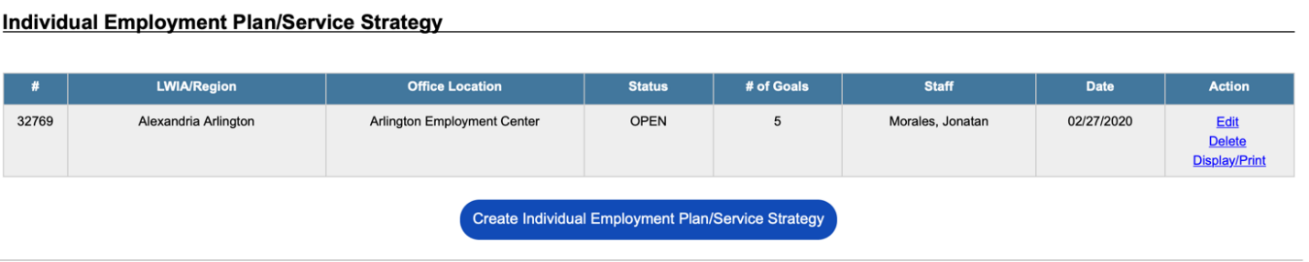
Ensure all Objectives and Goals are already closed by visiting those tabs.
Note: Remember, you must work from the “bottom up” when closing parts of a plan: Objectives first, then their associated Goals. All Objectives and Goals must be closed before the plan itself can be closed.

